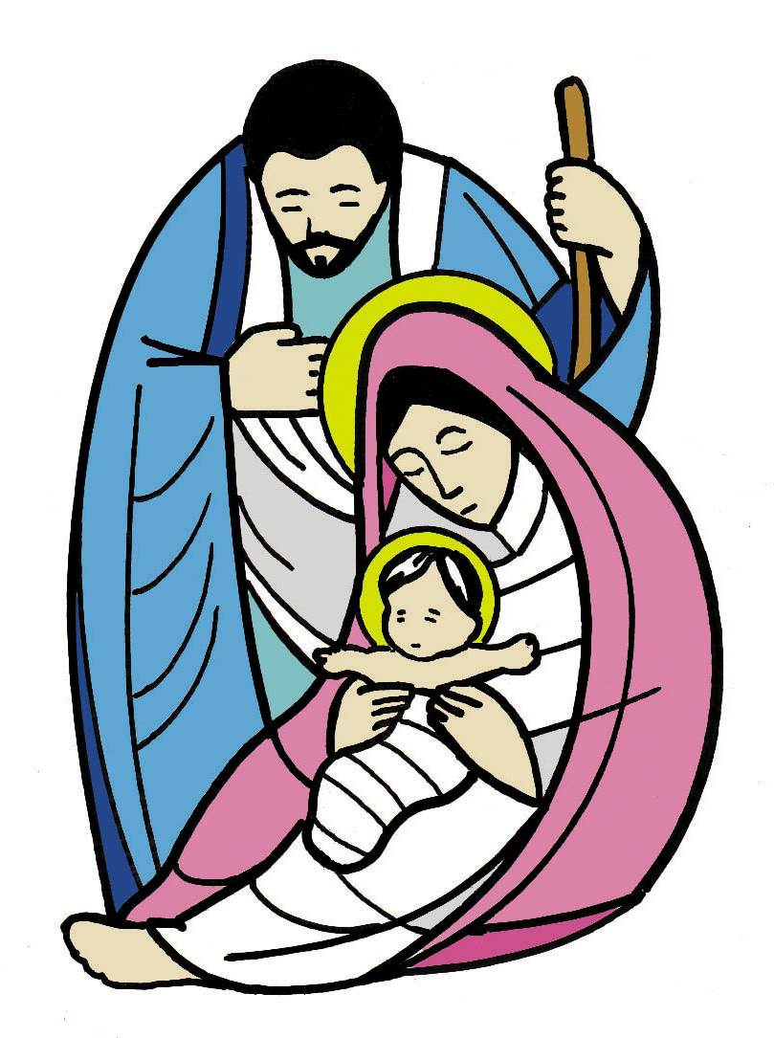

HOLY FAMILY RC PRIMARY SCHOOL
ROCHDALE

SCHOOL ADMISSIONS
POLICY
2024-2025

HOLY FAMILY RC PRIMARY SCHOOL

Mission Policy

Holy Family School exists to serve its parish and community by promoting excellence academic, creative and spiritual learning.

Based on the teachings of Jesus Christ and the Roman Catholic Church, the school seeks to provide a happy, safe and inspiring environment where children, staff, parents and visitors feel secure, loved and respected.

Holy Family Roman Catholic School encourages all its members:

Through WORK: to develop his or her full potential as part of the community and as a unique person made in the image and likeness of God.

Through WORSHIP: to learn to know and love God and to recognise and respond to the person of Christ in others.

Through WITNESS: to celebrate Gospel messages including justice and peace

This policy has been approved and adopted by staff and Governors

Signed ……………………………………… (Chair of Governors) Date ………………

Signed ……………………………………… (Headteacher) Date ………………

Holy Family is a Roman Catholic Primary School and Nursery provided by the Diocese of Salford and is maintained by Rochdale Local Authority as a voluntary aided primary school. The school’s governing body is the admission authority and is responsible for taking decisions on applicants for admission. For the school year commencing 2024/2025 the governing body’s planned admission number is 30. The Nursery class has a capacity of 26 part time places.

Admission to the school will be made by the governing body in accordance with the stated parental preferences it receives subject to the following criteria which will be used to form a priority order if there are more applications for admission than the school has places available.

The Catholic Faith and the Teachings of the Roman Catholic Church have an essential role in school life and influence every aspect of the Curriculum. We ask all parents applying for a place here to respect this ethos and its importance to the school community. This does not affect the right of parents who are not of the Faith of this school to apply for and be considered for a place at Holy Family RC Primary School & Nursery.

- Baptised Roman Catholic children and non-Roman Catholic children who are looked after or previously looked after including those children adopted from state care outside of England (LAC and IAPLAC children).
- Baptised Catholic children resident in the parishes in the parish of St Margaret Clitherow
- Other Baptised Catholic Children who have a sibling in the school at the time of admission

4. Other Baptised Roman Catholic children who will have a brother or sister attending

the school at the time of admission and are resident in another parish.

5. Other Baptised Roman Catholic children who are resident in another parish.

6. Exceptional Needs

7. Other children with a brother or sister attending the school at the time of admission.

8. Other children.

PRIMARY NOTES

a) The governing body is the admissions authority. The admissions committee is comprised of the following governors: Chair of governors, foundation governor and headteacher.

- b) In the autumn term all parents who have expressed an interest in a school
place will be sent a copy of the Local Authority ‘Primary Admission Booklet; which gives details of the LA co-ordinated admissions arrangements. These are available from Local Authority offices, public libraries and primary schools.

- c) Parents must complete a common application form and express 3 preferences for primary school admission. The closing date for all applicants is 15th January 2024. All applicants will be considered by the governors at the same time in a fair way according to the published criteria.

d) Supplementary Form
The supplementary form must only request information relating to the fact of baptism. Any further information usually collected by the school should be requested on admission.

e) Parents will be informed of the governors’ decision by LA on 15th April 2024. An offer of a place does not guarantee a place for brothers and sisters in subsequent years.

f) Each Roman Catholic applicant will be required to produce a baptismal certificate.

- g) Parents should check carefully whether they are resident within the parish boundaries of St Margaret Clitherow Parish and living in the following catchment area:
From the junction of Moss Bridge Road and Kingsway, East along A6193, to junction 21 on M62 Motorway, South by Newhey Road, Shaw Road, Milnrow Road to the point where it meets Shaw and Crompton and Newhey railway. By a beeline to and West along Mossgate Road to the point opposite Higher Rise (road), then by a beeline excluding all of Greenhill Avenue, crossing Rochdale Road and Castleton Road (near Gravel Hole Methodist Church, Pit Lane), to and West along Thornham Lane, to its junction with Oldham Way, and then following Oldham – Rochdale District boundary and by a bee-line to M62 junction 20 , North along the motorway to and East along Rochdale Canal Greenfield Lane, Queensway, Kingsway to the junction of Moss Bridge Road and Kingsway.

h) All applicants resident in the parish of Holy Family will be required to provide proof of address, by supplying an original, up-to-date, utility bill or family credit book.

i) It is the duty of governors to comply with class size limits at Key Stage One. This means that the school cannot operate classes in Key Stage One of more than 30 children.

j) Exceptional Needs
Children for whom the governors accept that there are exceptionally strong medical, social or welfare reasons associated with the child and/or family, which are directly relevant to
the school concerned. Supporting professional evidence will be required.

This may be from whatever sources/s the applicant feels are most appropriate. Examples of such evidence are doctors, health visitors and social services

Admission to a different year group: Consideration of places allocated to children whose dates of birth fall outside the conventional parameters of the year group will be considered under this heading.

Children of UK Service Personnel: Allocation of places to children of service personnel will also be considered under this heading.

k) Special Needs
If a child has a statement of special needs naming a specific school there is a duty
for the school to admit the child.

- l) If in any category there are more applications than places available, priority will be given on the basis of proximity to the school. This will be determined by the nearest, safest walking routes from the front door of the house to the main entrance door of the school. This will be digitally measured using the LA system.

m) Where a child lives with parents with shared responsibility, each part of the week, the ‘home’ address will be determined as being where the child resides for the majority of the school week.

n) The term ‘brothers and sisters’ will be taken to include step brothers and sisters, foster children and children of partners living in the same household. The governing body reserves the right to give special consideration to twins or triplets etc to prevent breaking the sibling link. However, the governing body must comply with maximum class size of 30 children.

o) If the school is oversubscribed, a waiting list will be maintained. This will be ordered according to the admission over-subscription criteria.

- p) Late applications will be considered in accordance with the published admissions criteria. If the school is over subscribed, late applications will be placed on a reserve list in priority order according to the published admissions criteria. Parents will be notified if a vacancy subsequently arises. Parents will be expected to provide a reason/s for the late application. If this is not exceptional the application will be dealt with after all others have been dealt with.

q) Parents are asked to read and confirm receipt of the Governors’ published admission policy. Any changes to the policy will be circulated to all applicants on file for subsequent years.

r) If an application for admission has been turned down by the governing body, parents can appeal to an independent appeals panel. This appeal must be sent in writing to the LA within 14 days of notification of refusal. The parents must give their reasons for appealing in writing on the appeals form provided and the decision of the appeals panel is binding on the governors. The outcome of the appeal is binding on the parents and on the governing body.

k. If a child is a “summer born child”, parents may request that the date their child is admitted to school is deferred to later in the school year. However, the child must start school before the end of that school year. If a parent wishes their child to be educated out of their normal school year (kept back a year), they must discuss this with the school before applying. However, the final decision on this rests with the headteacher.
l. Parents may request that their child attend school part-time until he/she reaches his/her fifth birthday.

Nursery Class Considerations

All 3 & 4 year old age eligible children will be eligible for;

- up to 15 free hours, these are classed as ‘universal hours.’
- some children will be eligible for up to 15 additional hours these will be known as the ‘extended entitlement.’ (the 30 hour entitlement)

Parent’s eligibility for the extended entitlement will have to be verified prior to child starting at the school. Schools should make clear to parents their position on the extended entitlement and their hours of operation.

The extended entitlement (30 hours) allows parents to access up to a further 15 hours entitlement per week, should they meet the eligibility criteria. Holy Family is able to offer additional afternoon sessions equating to 15 hours more than the basic entitlement. In order to access the basic 15 hours entitlement, children will be required to attend Nursery daily from 9am – 12 noon. Additional hours can be sought for the afternoon sessions. Holy Family Nursery is able to offer 26 places in the morning and again in the afternoon. The basic 15 hours cannot be taken flexibly however (i.e. in 2 block days).
Parents not eligible for the additional 15 hours provision are able to pay £10 per session for any extra afternoon sessions attended.

Parents should be made aware that there is no guarantee that a child, who is admitted to a school’s nursery class, will be admitted to the school full-time.

Parents of children in nursery classes should complete an application for a school place form in order to request a full-time place in school. The full-time admissions guidance has to be applied to determine which school has places.

Children are eligible to attend Nursery if they are 3 years of age before the 1st September of the year they wish to start. Holy Family does not admit children to Nursery each term unless there are places available. Should places be available, the following dates will be adhered to;

3YO’s born between | Month of admission | Term of admission
1 April – 31 August | September | Autumn
1 Sept – 31 Dec | January | Spring
1 Jan – 31 March | April | Summer

Parents interested in starting their child in Nursery at the start of the spring or summer term should first enquire at the school office as to the availability of Nursery places.

Attendance in Nursery

It is school’s responsibility to ensure that children are attending regularly and for the number of hours per week that are being claimed and detailed on the Parent Agreement Form. Occasional holidays and sickness absences are acceptable.

However as part of safeguarding arrangements Holy Family School will contact the parent/carer when a child does not attend. If no information relating to the reason for the absence has been received we will contact the parent on the first day of the child’s absence; reasons for absence will then be recorded on the child’s file along with the expected return date.

If the child does not return on the expected date then we will make a follow-up call to the parent/carer to establish reasons and whether the child is going to continue with their free place.

If any child has what is deemed to be irregular attendance then school will remind parents that the free place is a funded place and continued irregular attendance could lead to a reduction of hours or the place being withdrawn and offered to another child.

Where there is a persistent absence of more than two weeks in any term without a justifiable reason then school will notify parents/carers that the place will be offered to another child. We will specify to the parent the date that the place will be removed. The hours of non-attendance can be offered to another child.

