HOLY FAMILY RC PRIMARY SCHOOL
ROCHDALE

ATTENDANCE
POLICY

Mission Statement

Holy Family School exists to serve its Parish and Community by promoting excellence in academic, creative and spiritual leaning.
Based on the teachings of Jesus Christ and the Catholic Church the schools seeks to provide a happy, safe and inspiring environment where children, staff, parents, governors and visitors feel secure loved and respected.
Holy Family Roman Catholic Primary school encourages all:
- Through WORK, to develop his or her full potential as part of the community and as a unique person made in the image and likeness of God
- Through WORSHIP, to learn to know and love God and recognise the person of Christ in others
- Through WITNESS to celebrate the gospel messages including justice and peace

Through WORK, through WORSHIP, through WITNESS

AIMS
This school is committed to providing a full and efficient educational experience to all of its pupils. On the basis of equal opportunities, we will take measures to encourage regular and punctual attendance at school and in all lessons. We believe our pupils have the right to education and to do this they require continuity and progression in their learning. Consistent attendance is an essential foundation in order to achieve potential.

It is the policy of Holy Family RC Primary School to celebrate achievement. Attendance is a critical factor to a productive and successful school career, and as a school, we will organise and do all we can to ensure maximum attendance for all pupils. Any problems that impede full attendance will be identified and addressed as speedily as possible.

Our school will give a high priority to conveying to parents and pupils the importance of regular and punctual attendance. We recognise that parents have a vital role to play and that there is a need to establish strong home/school links and communication systems that can be utilised whenever there is a concern about attendance.

If there are problems that affect a student’s attendance we will investigate, identify and strive in partnership with parents, pupils and relevant support agencies as quickly and efficiently as possible. We will adopt a clearly focussed approach aimed at returning the pupil to full attendance at all times.

In accordance with Keeping Children Safe in Education (Sept 2023), it is every professionals’ responsibility to track and monitor children’s attendance and to follow up ANY unexplained absences. Equally, school office staff must ensure that more than one contact number is on record for each child to prevent cases slipping through the net or identifying at the first opportunity, safeguarding issues that may arise as a result of non-attendance.

This policy is adopted in school along with the Department for Education guidance ‘Working Together to Improve School Attendance’. This policy is also applied alongside statutory documents on children missing education, suspensions and exclusions, alternative provision and safeguarding.

Expectation
Pupils and parents can expect the following from school:
- A good education
- Promotion of good attendance
- A clear and fully understood registration process, in accordance with statutory regulations
- Regular, accurate and efficient recording of attendance
- Effective communication between school and home
- Speedy action on any problems identified
- Early contact with parents if a student fails to attend
- Nominated Governor with responsibility for overseeing attendance

We expect the following from pupils:
- That they will attend school regularly
- That they will arrive on time and appropriately prepared for the day
- That they will speak to a member of staff if experiencing problems in school (Mrs Collins is responsible for operating the First Response system along with Miss Kershaw and Mrs Nightingale monitors attendance with Mrs Arnold)
- That they will accept help, support and guidance when offered and deemed appropriate.

We expect the following from pupils and parents:
- To ensure that their children attend school
- To ensure that they contact school whenever any problem occurs that may keep them away from school
- To ensure that they contact school daily if their child in unable to attend
- To ensure that their children arrive in school well prepared for the school day
- To understand that a minimum of 95% attendance is expected by school and the LA.
If a student continue to attends for only 90% of the time then over 5 years, he/she will miss the equivalent of about one half of a school year.
Research suggests that 17 days missed from school in Year 11 equates to a GCSE grade.

Encouraging Attendance
School will encourage attendance in the following ways:
- Set appropriate targets for individuals, groups and school
- Accurate completion of registers at the beginning of each session and at the start of each lesson
- Attendance checks at appropriate times
- Recording of good attendance in individual records of achievement and progress files
- A certificate for 100% attendance in any one term
- Attendance Ted to be awarded to the year group with the best attendance for each week across the Key Stage
- On-time Ted awarded weekly to the class from each Key Stage with the fewest number of lates
- Targeting pupils who have attendance problems through making contact with home, intervention of Learning Mentor and contact made with EWO
- Holding Parent consultation meetings early in each term, for those parents who are concerned that their children may be experiencing difficulties that may impact upon attendance
- Sending parents attendance figures in pupil reports, as part of assessment data
- Act upon parental, staff and agency requests for support with attendance issues, in an appropriate and flexible manner
- Put in place preventative procedures wherever possible
- Offer a range of interventions and support aimed at overcoming barriers to learning of which may impact upon attendance
- Appropriate liaison with external agencies

Types of Absence
Authorised absence
REMEMBER: Only the Head can authorise absence and will only do so in exceptional and extreme circumstances. Parents cannot authorise absence.
- Illness (if absence is prolonged, the Head may decide not to authorise the absence without medical advice)
- Unavoidable medical appointments when supported by official medical documentation
- Recognised religious observance

In 2013, the Government issued advice to schools instructing that NO extended absences can be authorised by school unless the circumstances are exceptional and extreme.
- The Head can authorise holiday leave in exceptional circumstances only
This must be agreed to before the holiday begins: This is NOT an entitlement and holidays taken in term time will adversely affect your child’s attendance record.
All pupils, who in exceptional circumstances, are granted holiday leave will be expected to make up work lost.

The Head will not authorise absence in the following circumstances:
- Shopping
- Birthdays
- Looking after other family members
- Waiting in for trades people
- Any holidays
- Unapproved sporting events
- Continued lateness to school
- Excessive absences without medical evidence
Unauthorised Absence
Truancy which includes:
- Unexplained absence (no note/contact from parents/carer)
- An unacceptable reason for the absence is provided
Responding to Non-Attendance
When a pupil does not attend school, we will respond in the following manner:
- Our Administrative Assistant will contact home on the first day of absence to;
  - make parents aware that the student is absent
  - ask for explanation for the absence
  - log parental responses in order to determine appropriate register coding
- If contact is not possible in the first instance, every contact number available will be attempted.
- The school base of any siblings will also be contacted to ascertain the child’s whereabouts.
- If contact is not possible, a home visit will be made by the Headteacher or Pastoral Lead.
- If contact is still not made, a NOTIFICATION OF ABSENCE letter will be sent by hand to the parents/carers in which they will be asked to contact school
- The staff with responsibility for monitoring attendance will notify the relevant teacher/ member of SLT of any failure to obtain an adequate reason for absence.
- If an unacceptable reason for absence is not provided the absence will be classified as unauthorised. Unauthorised absence may result in intervention form a representative from the Attendance and Behaviour Service.
- In the case of persistent non-attendance and following a set period of intervention by the Attendance Officer, we will support any recommendations for statutory action by the attendance and safeguarding team, acting on behalf of the Local Authority.
PLEASE NOTE:
The Education Act 1996 clearly states: ‘If any child of compulsory school age who is a registered pupil at school, fails to attend regularly, the parent of the child shall be guilty of an offence.’
The Attendance and Safeguarding Team will consider any requests from the Head to issue Penalty Notices to parents/carers when a student has received a period of unauthorised absence in a current term of at least 10 sessions (5 days). This may result in the parent/carer being issued with a fixed penalty notice fine (£60 per parent, per child). The issuing of a Penalty Notice is considered appropriate in the following circumstances:
- Overt truancy (including pupils caught on truancy sweeps)
- Parentally-condoned absences
- Excessive holidays in term time
- Excessive delayed return from extended holidays without prior school agreement
- Persistent late arrival at school (after the register has closed)
- 20 absences or more over a half term period

REINTEGRATION
The return to school for a pupil after a long term absence requires special individualised planning. The Attendance Officer, HEADTEACHER and Pastoral Lead will be responsible for deciding on the programme of return and the management of that programme. All staff need to be aware that this is a difficult process that will require careful handling and that nay problems should be notified to the relevant staff as soon as possible.

Programmes will be tailored to individual needs and may involve phased, part-time re-entry with support in lessons as appropriate.

Support will be arranged between the Attendance Officer, Pastoral Lead, Head and Inclusion Manager (if appropriate).

Parents will be involved and informed at each stage of the planned reintegration.
All strategies will be fully logged on and form part of the pupils’ pastoral and academic file.
Staff will be notified of the return of long term absences via staff briefing sessions and the school bulletin.
Working Together to Improve School Attendance
Since the return to school following the Covid pandemic, good attendance and punctuality is more important than ever and, to that end, school will raise the profile of attendance to ensure that good routines are established and embedded in this new academic year.
‘Late stops’, attendance reviews and communication home to parents will be used to alert them to any concerning trends in attendance and punctuality. Parents should expect a consistent message from school about daily attendance and the cost to children’s education caused by the disruption to learning over the last 3 years.
We recognise that parents’ and children’s anxieties and emotional well-being continue to be adversely affected by the disruption to school and pandemic related restrictions. Support is in place through our Pastoral Lead, Children’s Counsellor and school based Social Worker, who are all available via the school office.
School will work with parents to overcome any difficulties and provide support where necessary. However, fines and penalties will be issued in accordance with the policy if attendance issues persist.
In accordance with this policy, school will adhere to the guidance issued by the DfE in September 2022 (revised in 2023) to improve attendance for all pupils, particularly those classed as persistently or severely absent (<90% and <50% respectively). The breakdown from the guidance below outlines the approach adopted by school:
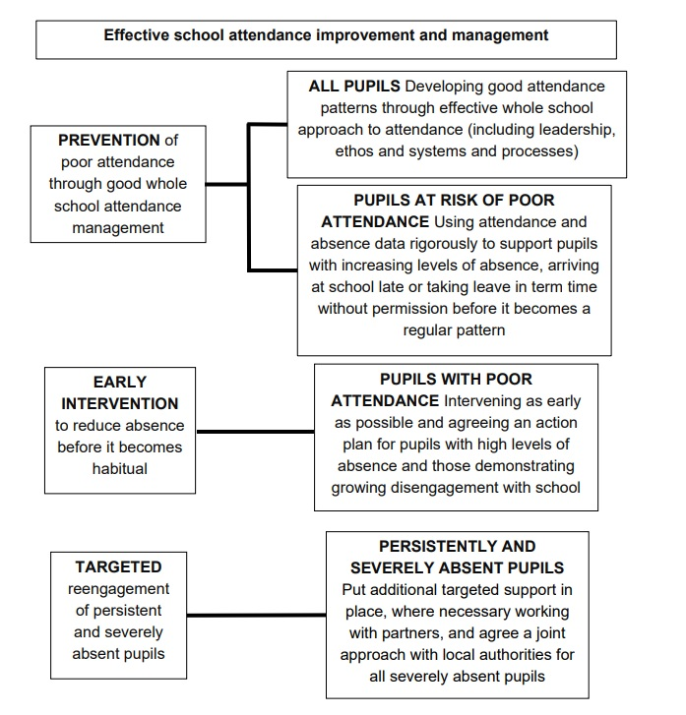
HOLY FAMILY SCHOOL
Procedures for Staff
In order for this policy to be successful, every member of staff must make attendance a high priority along with the importance of the education being provided. All staff; teaching and non-teaching, must lead by example.
In addition to this, there are the following responsibilities:
HEAD
- To oversee and keep attendance and procedural policy under review with the SLT and Governors
- To report to Governors on the levels of attendance.
- Distribute rewards and incentives weekly and termly.

PASTORAL LEAD
- Challenge absences on a daily/weekly basis with individuals.
- Operate first response calling (in absence of administrative officer).
- Praise and reward good attendance on an individual and group basis.
- Challenge any anomalies in weekly/daily attendance
- Request parental letters explaining absences
- Encourage/advise individual pupils on the importance of attendance and punctuality
- Monitor all pupils’ attendance, especially those pupils who have been referred to the Attendance Officer. Advise and recommend to the Attendance Officer and Head on trends of attendance and areas of concern.
- To act as a conduit for the flow of information concerning attendance between school and parents.
- To challenge lateness to school with pupils and inform parents.
- To challenge parents in all cases of absence.

CLASS TEACHERS

- To complete the register accurately and within the first 10 minutes of each lesson.
- To amend the register as necessary during the course of the lesson. To challenge non-attendance in lessons.
- To advise pupils of the impact of non-attendance on attainment and progress.
- To inform individuals of work missed due to absence from lessons.
- To raise attendance concerns with Pastoral Lead and/or Head.

ADMINISTRATIVE SUPPORT

- Operate First Response system
- To advise the Attendance Officer of any incidents of inaccuracy for relevant action.
- To assist the Attendance Officer as necessary.
- To ensure pupils leaving school are signed out and late arrivals are appropriately signed in.

ATTENDANCE OFFICER/PASTORAL LEAD

- To set and monitor targets for individuals, groups and years.
- To liaise with SLT and Headteacher over the attendance and registration systems and the collation of attendance data.
- To produce the Attendance Profile for the whole school.
- To report to the SLT on attendance matters
- To oversee the registration process
- To liaise between home and school in cases of pupils with poor attendance
- To conduct home visits based upon poor attendance.
- To manage referrals to Education Welfare Service as necessary
- To liaise with relevant individuals in cases of reintegration for pupils with poor attendance.
- To meet with Attendance and Safeguarding Team on a regular basis, to discuss individual cases with concerns on attendance.
- To meet with LA EWO on termly basis to review attendance and agree plan of action for cases causing concern.
- To monitor a cohort of pupils on attendance of below 85%. Interview as necessary and make regular contact.

See also Appendix i (LA Attendance Policy Statement) & Appendix ii (Application for Extended Absence from School form).

This policy has been approved and adopted by staff and Governors

Signed ……………………………………… (Chair of Governors) Date ………………

Signed ……………………………………… (Headteacher) Date ………………

GB Review 15.09.23 – changes highlighted yellow

