HOLY FAMILY RC PRIMARY SCHOOL
ROCHDALE

SINGLE EQUALITY & COMMUNITY COHESION POLICY

North West Diocesan Statement of Equal Opportunities in Employment

The principle of equal opportunity for all is consistent with social justice and with the Christian ideal of recognising the dignity and worth of all who work or wish to work in our schools. The Governing Body is therefore committed to employment procedures which comply with civil law and do not discriminate on grounds of age, gender, race, colour, nationality, religion, sexual orientation, gender reassignment, pregnancy and maternity and ethnic origin or disability.

We recognise and value the current and future contribution to our school of staff who while not sharing our Catholic faith make a strong and sincere commitment to the schools Christian values and Mission Statement.

Some teaching posts include specific responsibility for providing leadership and direction in the religious life and Catholic identity of the school. In other appointments, where two or more candidates for teaching posts are equally strong in the context of the criteria for appointment, preference may be given to a candidate who is Catholic.

In addition, the Governing Body recognises that the school and our Catholic teachers are called to be witnesses to Christ’s teachings. We therefore reserve the right as employers to take into consideration any personal behaviour or circumstances which are outside the recognised norms of the Church and which are genuinely within an individual’s control. In doing so, we will seek always to give witness to the Christian pastoral principles of love, respect and reconciliation.

1. Purpose of the Policy

This Equality & Diversity policy sets out our commitment to tackling discrimination and promoting equality of opportunity and good relations, and explains what this means for the whole school community. This policy has been written to meet the school’s legal duties in relation to race, gender, disability and community cohesion. The policy also meets legislation on age, religion or belief and sexual orientation.

This Equality & Community Cohesion Policy brings together our race, disability and gender Equality policy and the duty to promote community cohesion and states how we propose to meet the general and specific requirements under the race, disability and gender equality duty.

The overall objective of Holy Family RC Primary School’s Equality & Community Cohesion Policy is to provide a framework for the school to pursue its equality duties to eliminate unlawful discrimination and harassment; promote equality of opportunity; and promote good relations and positive attitudes between people of diverse backgrounds in all its activities.

The principles of this policy apply to all members of the extended school community – pupils, staff, governors, parents and community members. Partners and contractors are also expected to abide by the policy.

The policy will be linked to a joint action plan which sets out how we intend to implement the policy over the next twelve months. Progress against the action plan and the policy itself will be regularly reviewed so that it continues to develop.

Name of School: Holy Family RC Primary School
Head Teacher: Mrs Helen Arnold
Chair of Governors: Mrs Maureen Conlon
Date Policy Created: 14th September 2009
Date Policy was reviewed and updated: 06th January 2023
Next review Date: 1st February 2024

2. Introduction

We welcome the equality duties on schools, and regard these as essential for achieving equality for every child.

We believe that all pupils and members of staff should have the opportunity to fulfil their potential whatever their background, identity and circumstance. We are committed to creating a community that recognises and celebrates difference within a culture of respect and cooperation. We appreciate that a culture which promotes equality will create a positive environment and a shared sense of belonging for all who work, learn and use the services of our school.

We recognise that equality will only be achieved by the whole school community working together – our learners, staff, governors and parents in particular. Throughout this policy, ‘parents’ can be taken to mean mothers, fathers, carers and other adults responsible for caring for a child.

This Equality & Community Cohesion Policy provides a framework for our school to promote equality, inclusion and good community relations, and to tackle prejudice, discrimination and their causes in a holistic and proactive way.

Our Single Equality & Community Cohesion Policy is based on the core principles that its effectiveness will be determined by:

- active involvement with key stakeholders, not just in developing this Policy but also in its review and implementation
- proactive leadership
- prioritising activities that produce specific, tangible improved outcomes
- removal of attitudinal and cultural barriers

We have incorporated our individual policy for race equality, and our disability and gender equality schemes into one overarching Equality & Community Cohesion Policy to create a coherent framework for promoting equality and diversity within our school. We have identified a set of priorities to promote equality, inclusion and community cohesion. Our Policy includes a plan of actions to address these priorities over the next three years.

We recognise that improving outcomes such as attendance or attainment for a specific group of pupils will help to improve our outcomes for all. Our commitment to equality is thus a fundamental part of our drive towards excellence.

3. Equality & Community Cohesion Statement

We will not tolerate less favourable treatment of anyone on the grounds of race, disability, gender, sexual orientation, gender reassignment or identity, age, religion or belief and socio-economic circumstances.

Through this policy, Holy Family RC Primary School seeks to ensure that no member of the school community, or any person through their contact with the school, receives less favourable treatment on any grounds which cannot be shown to be justified. This covers race, colour, nationality, ethnic or national origin, religion or belief, gender, marital status, responsibility for children or other dependents, disability, sexual orientation, gender reassignment, gender identity, age or socio-economic background.

Equality and Diversity is more than just meeting legal obligations, or targets. It’s about making a difference to the lives of the people we serve, treating all people with dignity and respect, and recognising the value of each individual. This means an ongoing commitment to ensuring that our services meet the varied and individual needs of children and young people in our school.

We will make sure that our employment practices are fair and promote equality. We will actively value the wide variety of lifestyles and cultures, locally and nationally. We will prepare children and young people for living in a diverse society with increasing global connections and controversial issues. We will ensure that the principles of this policy are reflected in all our policies, practices, procedures and services and are part of everything we do.

Holy Family RC Primary School
Mission Statement

Holy Family School exists to serve its Parish and Community by promoting excellence an academic, creative and spiritual learning.

Based on the teachings of Jesus Christ and the Roman Catholic Church, the school seeks to provide a happy, organised and inspirational environment where children, staff, parents and visitors feel secure, loved and respected.

Holy Family RC Primary School encourages its members
- Through WORK, to develop his or her potential as part of the community and as a unique person made in the image and likeness of God
- Through WORSHIP, to learn to know and love God and to recognise and respond to the person of Christ in others
- Through WITNESS, to celebrate Gospel messages including justice and peace.

4. The Legal Context

There were a number of statutory duties that the school was required to meet prior to the Equality Act 2010. As such, with the implementation of this act and the harmonisation of previous legislation, this policy will refer to the Equality Act 2010 and its various provisions as the legislative framework through which this Single Equality and Community Cohesion Policy will operate.
All schools have duties to promote race, disability and gender equality.

In the development of this Single Equality and Community Cohesion Policy Holy Family RC Primary School has moved from a focus on an individual response to an approach that builds on disability, gender, gender reassignment, pregnancy and maternity, race, religion or belief and sexual orientation considerations from the start and at every level of the school, at strategic, policy, management and classroom level. We will demonstrate what we have done and what we plan to do to improve opportunities and outcomes for pupils, staff, parents and other users of the school. This policy will be monitored and delivered through the governors’ role, School Improvement and Self Evaluation process.

We will ensure that every pupil irrespective of the protected characteristics is able to achieve high standards and that strategies are in place to tackle under–achievement. We will ensure that every pupil has access to the necessary support required to enable them to achieve their highest potential. We will ensure that the school’s procedures for disciplining pupils and managing behaviour are fair, effective and equitable.

Our intention is to ensure that the adults working or volunteering in the school include as much as possible a balanced representation of the local and wider community. We believe that this will provide good role models for pupils from all backgrounds.

This Single Equality and Community Cohesion Policy will be linked to a joint action plan which sets out how we intend to implement the policy over the next three years.

Holy Family RC Primary School sees this Single Equality and Community Cohesion Policy as a living document and we will continuously review the action plan in consultation with pupils, staff, parents, carers, governors and all other stakeholders where possible. We believe they need to be involved from the very start and their involvement will inform the preparation, development, publication, review and reporting of the policy and action plan to ensure that we meet the needs of people from different backgrounds.

As a school we are fully committed to the public sector duty which came into force from April 2011 and as such will endeavour through policy and practice to eliminate prohibited conduct, advance equality of opportunity and foster good relations for all members of our school community.

Schools have a duty to promote community cohesion, developing good relations across different cultures, ethnic, religious and non-religious and socio-economic groups. There are no statutory requirements for schools to have a policy or action plan for promoting community cohesion. However, we have incorporated our priorities into our Single Equality & Community Cohesion Policy and Action plan to make it easier to monitor our progress and performance in meeting the requirements of this duty.

Although there are no equivalent promotional duties in relation to age, sexual orientation and religion or belief, we must ensure that we do not discriminate on these grounds. This Policy includes our priorities and actions to eliminate discrimination and harassment for these equality areas.
Appendix A provides further details of the requirements of equality legislation.

5. Local and School Context

Local Context:
Rochdale Borough serves a total population of 204,700, with 83,458 households in the borough. This is expected to grow to a population over 212,300 by 2033. Rochdale Borough covers 62 square miles, there is a mix of urban and rural areas and over two thirds of the borough is covered by countryside and green areas. It contains four townships (Heywood, Middleton, Pennines and Rochdale). We have excellent links to Greater Manchester and other cites in the region and easy access to magnificent countryside including the Pennines.

Rochdale Borough is ranked one of the most deprived boroughs in the country and is ranked 25th out of a total of 354 using the indices of multiple deprivations. The Borough has challenges with respect to low economic growth, poor life expectancy, higher levels of crime, low skill, high levels of people living in poverty, poor physical environment.

Rochdale Borough is made up of 135 Lower Super Output Areas and of these 16 are in the 3% most deprived in England, 36 are in the 10% most deprived in England and 57 are in the 20% most deprived in England (based on indices of deprivation 2004). Deprivation is highest in parts of West Heywood, West Middleton, Kirkholt, Smallbridge, Firgrove and the centre of Rochdale.

Statistics show that 83.5% of the Borough’s population are from a White British ethnic background. People from a Pakistani background make up the largest minority ethnic group with 7.71% of the population. White Irish make up the second highest minority group at 1.46%, followed by Bangladeshi’s at 1.26%. Overall 25% of the school population are from minority ethnic groups.

Rochdale Borough’s population is younger than that of Greater Manchester and England & Wales. The greatest difference is in the 0-15 year olds age group (21% compared with national average of 19%).
Disabled people form approximately 19% of the working age population of the Borough. It is estimated that some 53% of disabled people of working age are unemployed.
There are more females than males in the Borough; with approximately 51.4% women compared with 48.6% males.
Christians form the main religious group in Rochdale with 72.10% of the total population. The next largest religious group is Muslims with 9.37% of people in the Borough. 1 in 7 people in the borough described themselves as having no religion.

b) School Context:
Holy Family RC Primary School situated in the town of Rochdale Borough in Rochdale and has 234 pupils on roll, aged between 3 and 11.

School Information

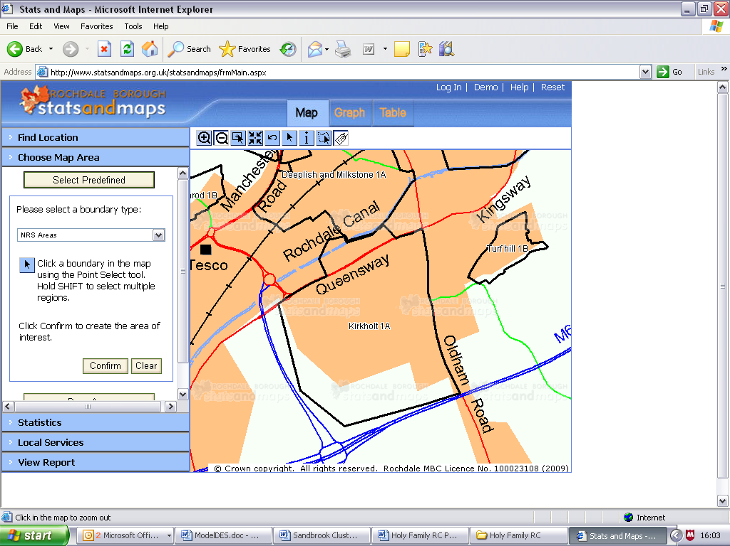
Holy Family RC Primary and Nursery School
Equality & Community Cohesion Information

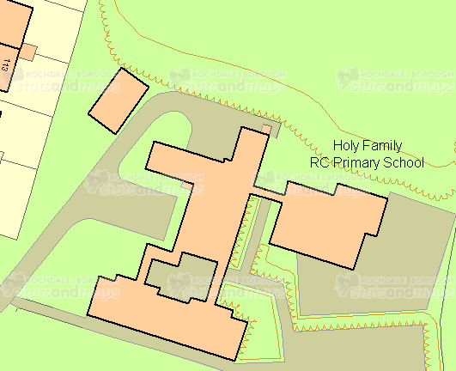
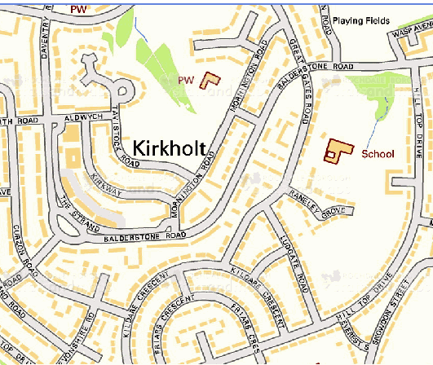

Ward Area –Balderstone & Kirkholt

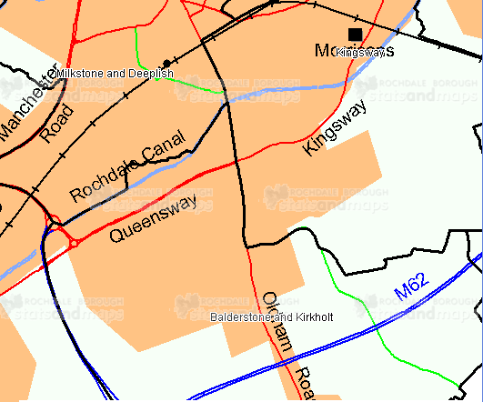
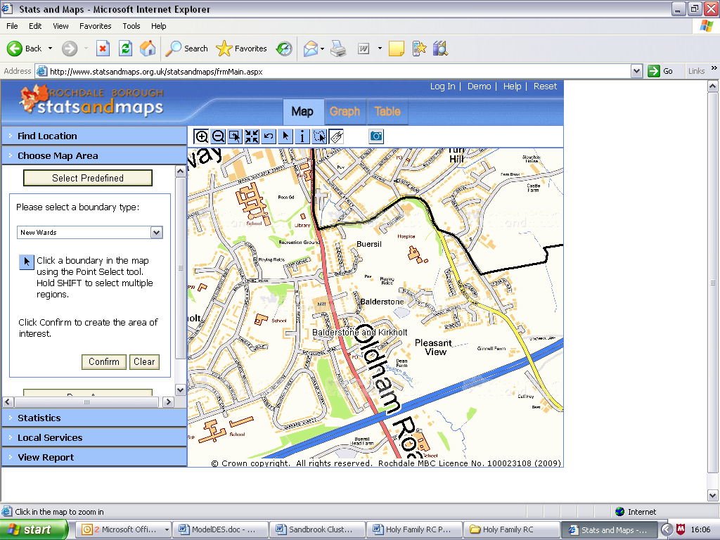

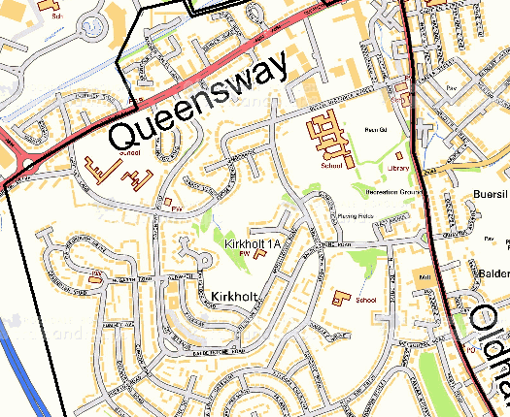
NRS Area – Kirkholt– Profile attached

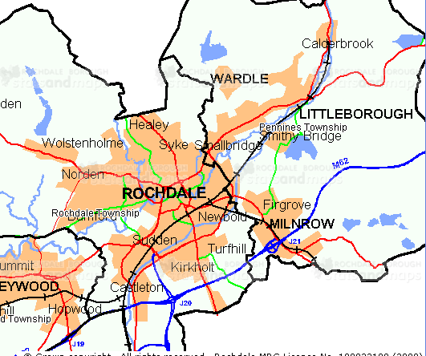

Township –Rochdale– Profile attached

LSO Areas – E01005466. Lower Super Output Area

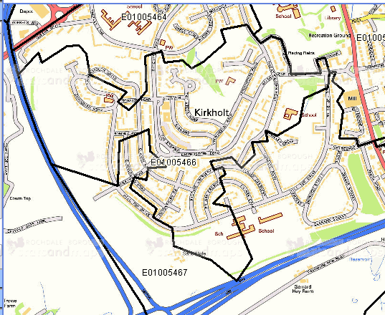

Overall Deprivation IMD for Lower Super Output Areas as RATES
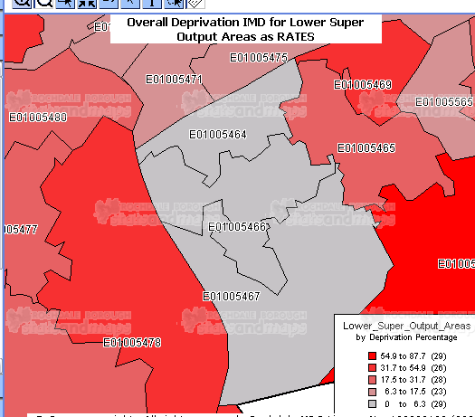
Name | Deprivation Percentage | Deprivation Rank
E01005466 | 0.05% | 17

Age

Name | 0 to 15 years | 16 to 29 years | 30 to 44 years | 45 to 59 years | 60 to 74 years | 75 years plus | All people
ROCHDALE | 22.83 | 17.12 | 22.15 | 19.02 | 12.35 | 6.53 | 100
MANCHESTER | 21.24 | 18.26 | 22.45 | 18.35 | 12.72 | 6.98 | 100
ENGLAND AND WALES | 20.15 | 17.51 | 22.55 | 18.93 | 13.28 | 7.58 | 100
Balderstone and Kirkholt | 23.92 | 16.32 | 21.8 | 17.9 | 12.93 | 7.13 | 100

Religion

Name | Christian | Muslim | Other Religions | No Religion | Religion not Stated | Total People
ROCHDALE | 72.1 | 9.37 | 0.63 | 10.79 | 7.11 | 100
MANCHESTER | 74.15 | 5.04 | 2.1 | 11.33 | 7.37 | 100
ENGLAND AND WALES | 71.74 | 3.1 | 2.88 | 14.59 | 7.69 | 100
Balderstone and Kirkholt | 73.95 | 4.91 | 0.52 | 12.24 | 8.38 | 100

Ethnicity

Name | White British | White Irish | White Other | Mixed | Pakistani | Bangladeshi | Other Asian | Black or Chinese or other | All people
ROCHDALE | 86.09 | 1.46 | 1.02 | 0.93 | 7.71 | 1.26 | 0.83 | 0.7 | 100
MANCHESTER | 87.95 | 1.72 | 1.4 | 1.33 | 3.03 | 0.81 | 1.8 | 1.97 | 100
ENGLAND AND WALES | 0 | 0 | 0 | 0 | 0 | 0 | 0 | 0 | 0
Balderstone and Kirkholt | 89.78 | 2.04 | 1.22 | 0.86 | 4.56 | 0.15 | 0.69 | 0.69 | 100

The Attainment Gap in the Percentage of Pupils Achieving Related Expectations in English and Mathematics at Key Stage 2 2022

Establishment name | % of Cohort FSM Eligible | % of FSM Pupils ARE in English and maths | % of all Pupils ARE in English and maths | Gap
Holy Family Roman Catholic Primary School | 43.3% | 53.8% | 73.3% | -20.5%

Of the children who are of compulsory school age as at 06.01.23:
- 38.4% of students have a free school meal entitlement
- 28.2% of students have English as an additional language

English | Punjabi | Polish | Portuguese | Urdu | Ukranian | Arabic | Czech | Edo/Bini | French | Chinese (Mandarin)
165 | 4 | 23 | 6 | 9 | 1 | 1 | 1 | 2 | 2 | 1
Igbo | Lingala | Persian/Farsi | Sinhala | Tigrinya | German | Nepali | Chinese  (Cantonese) | Sign Lang | Yoruba | Romanian
1 | 1 | 1 | 1 | 1 | 1 | 1 | 1 | 1 | 1 | 2

18.94% pupils have Special Educational Needs.
EHC Plans
5

Gender mix
Girls | Boys
102 | 125

Ethnicity
Any other Asian  bckgnd | Any other Black bckgnd | Any other mixed bckgnd | Any other White bckgnd | Black African | Pakistani | White British | Other Ethnic Group
7 | 4 | 3 | 31 | 36 | 12 | 118 | 16

Religion
Christian | Muslim | No Religion | Refused | Sikh | Roman Catholic | Other Religion
38 | 13 | 48 | 2 | 0 | 116 | 10

Free School Meals
Free School Meals | Non Free School Meals
85 | 142

English as an Additional Language
EAL Children | Non EAL Children
64 | 163

Staff
Ten teachers are supported by 14 support staff and these are categorised as follows:
Male | Female
1 | 23

White British | Any other Asian Background | White Irish
20 | 2 | 2

Roman Catholic | Non Roman Catholic
16 | 9

With disability | Without disability
0 | 23

Description of Holy Family RC Primary School
- We are a Roman Catholic Primary School with PT Nursery provision.
- There are strong links with church and parish which enrich pupils’ religious, spiritual, moral and social education.

The school’s church links contribute a valuable dimension to its Catholic ethos.
- The NOR is 234. All classes are full with the exception of Year 6 and Reception which each have 2 places as a result of pupil movement this year. For many classes there exists a waiting list.
- This school is a popular choice with parents and each year is over-subscribed.
- The school is 1 form entry, 8 classes, and with a PAN of 30, all learners are taught in single age classes.
- The children come from an area of very high economic disadvantage.
- Out of 135 Lower Super Output Areas in the Borough of Rochdale, Kirkholt is 16 out of 135 most deprived areas in the borough and in the 3% most deprived in England.
- The percentage of pupils known to be eligible for free school meals is 38.4%.
- Kirkholt is an area with high unemployment and crime statistics.
- Drug and alcohol abuse is prevalent in the community.
- Pupil attainment on entry to the Nursery is below average.
- The majority of pupils show significant language delay when assessed on entry into school. 80% of our pupils are below age related expectations on entry to Nursery, compared with 50% nationally. We are in one of the most deprived areas in Rochdale.
- The school makes excellent provision for pupils with SEN and they perform well for their ability.
- The school has achieved: Enhanced Healthy Schools Award, Eco-Schools Green Flag Award, Platinum School Sports Award, Golden Grin Award, School Council Bronze Award, P4C Bronze Award, PSQM and International School Bronze Award.

The school makes very good provision for pupils from ethnic minority and EAL backgrounds.
- The school has strong community links with neighbouring schools, Emmaus Federation and St Cuthbert’s RC High School.

Structure of our Single Equality and Community Cohesion Policy

This policy document is designed to give a background to Holy Family RC Primary School in respect of the protected characteristics in both education and service provision.

Recruitment and employment issues with regard to staff may be referenced but these will be covered in more detail under separate policy.

Therefore, we have set out below:

- The definitions in respect of each of the protected equality characteristics
- Our commitment for each of the protected equality characteristics
- Our headline achievements, aims and objectives for each of the protected equality characteristics

We have then set out our key approaches and tools to help us achieve these aims including:
- Our consultation and involvement strategy
- Our commitment to Equality Impact Assessments
- Our accountability processes for the policy
- Our commitment to publication and public access
- Our monitoring and review processes

Specific Equality Areas

Disability

What do we mean by Disability Equality?
We recognise that a person has a disability if they have a physical or mental impairment which has a substantial and long-term adverse effect on their ability to carry out normal day-to-day activities.

Our commitment
Holy Family RC Primary School is committed to promoting an ethos that safeguards the dignity and well being of everyone and encourages practices that take into account the rights of individuals to be treated with dignity and respect. We will not tolerate any form of discrimination, harassment and victimisation directed at anyone because of their disability.

This Single Equality and Community Cohesion Policy incorporates our commitment and actions on disability equality. It demonstrates our commitment to addressing disability equality in our decision making and the delivery of education.

We are committed to promoting equality of opportunity for disabled pupils, staff and other users of our services so they can have equal access to all our school and its services. This policy is a statement of our commitment and shows clearly how we will work over the next three years to achieve our goal.

We will continue to review our policies, practices and procedures so that they do not adversely affect anyone because of their disability. By also building this into our curriculum, working and procurement processes we will expect others to do the same.

Our Achievements
We have in place an up to date Accessibility Plan. An Asset Management Plan addresses the need for areas to be accessed by all and for pupils and staff to learn and work in a safe and comfortable environment.

We are a very inclusive school, accommodating children with mild to moderate disabilities that are thriving in school. There have been no exclusions in the last 4 years.
Christ’s example defines everything that we do in school; each person is treated as special and we believe that we are all made in God’s image. Our Mission Statement underpins our care of one another and every aspect of the work that we do.

Our Aims and objectives
We have identified a number of specific actions designed to promote positive attitudes towards disabled people. We have committed to:
- Representing disabled and able bodied people equally and positively in school documentation and marketing tools.
- ‘Statements to Live By’ that focus on the value of one another. These are communicated to parents as well as through work in school.
- Children and staff are encouraged to take a full and active part in the many groups and activities that take place in school; Eco Team, School Council, Anti-Bullying Team, Paired Readers, after school clubs, Community Ambassadors, Chaplaincy Team, Sports Leaders etc.

Gender

What do we mean by Gender Equality?
We recognise that a person’s gender refers to the fact that they are male or female or identify themselves as male, female or non-binary. In relation to a group of people, it refers to either men or women or to boys or girls.

Our commitment
Holy Family RC Primary School is committed to promoting an ethos that safeguards the dignity and well being of everyone and encourages practices that take into account the rights of individuals to be treated with dignity and respect. We will not tolerate any form of discrimination, harassment and victimisation directed at anyone because of their gender or identity.

We recognise that stereotypes exist for both genders and some can lose opportunities because of these stereotypes and welcome the requirements of the Equality Act 2010 with specific provision for Gender Equality and we will give due regard to the need to:

- Eliminate unlawful discrimination and harassment on the grounds of gender, including domestic violence, sexual violence, bullying and exploitation.

- Promote equality of opportunity between women and men in all of our functions.

Our achievements
- We have high expectations for all of our pupils regardless of gender. Performance of pupils from each group is carefully tracked and strategies and support put in place to enable all pupils to achieve in line with expectations.
- We encourage all of our staff and pupils to aspire to be the best. Opportunities exist for all individuals to participate in every activity on offer in school.
- Positive role models are sought out to speak and present to the children (Career’s Week, curriculum enrichment, links with Rochdale Hornets, RAFC, Emmaus Federation). These opportunities help to address gender stereotyping in many aspects of school, work and wider society.
- We observe an anti-bullying week each year and raise the issue of unfair treatment of one another on account of our differences. We treat with great seriousness any accounts or reports of bullying and recognise that as a school, we are not immune from such incidents.
- Governors and Headteacher are sympathetic to the needs and commitments of all staff. Consideration is given to staff with children and other dependents and in certain circumstances, flexible working has been applied.
- Every effort is made to ensure that all sexes are portrayed positively in school.

Our Aims and objectives
We have identified a number of specific actions designed to promote positive attitudes towards greater gender equality. We have committed to:
- Further advance the achievements and opportunities for all children; particularly boys’ writing and achievement of girls in maths.
- Offer wider opportunities for all children in sports, performing arts and inter-school competitions.
- Encourage career progression and CPD opportunities for all staff of both genders.

Gender Reassignment

What do we mean by gender reassignment?
We recognise that a person may express their gender in a way that differs from or is inconsistent with the physical gender that they were born with.

Our commitment
Holy Family RC Primary School is committed to promoting an ethos that safeguards the dignity and well being of everyone and encourages practices that take into account the rights of individuals to be treated with dignity and respect. We will not tolerate any form of discrimination, harassment and victimisation directed at anyone because they propose to undergo, are undergoing or have undergone gender reassignment.

We understand gender reassignment does not necessarily require a medical process to be undertaken and that a person will be protected because of gender reassignment if they:
- Make their intention known to someone at the school
- Start to behave or dress according to the gender they identify with
- Undergo treatment such as surgery or hormone therapy
- Have already received gender recognition under the gender recognition act 2004

The school will also respect the confidentiality of those seeking gender reassignment and will provide a supportive environment within its school community.

Pregnancy and maternity

What do we mean by pregnancy and maternity?
Treating a woman (or a female pupil of any age) less favourably because she is or has been pregnant, has given birth in the last 26 weeks or is breastfeeding a baby who is 26 weeks or younger.

Our commitment
Holy Family RC Primary School is committed to promoting an ethos that safeguards the dignity and well being of everyone and encourages practices that take into account the rights of individuals to be treated with dignity and respect. We will not tolerate any form of discrimination, harassment and victimisation directed at anyone because of their pregnancy or maternity.

We will also seek to make arrangements for female pupils or staff to ensure that they are not treated less favourably because they are pregnant or breastfeeding.

We will not discriminate against a pupils or staff in absences related to pregnancy and maternity.

Our achievements
- Several members of staff have been on maternity leave in recent years. The school applies LA policies to absences and honours appointments and absences related to pregnancies.
- Staff are treated with respect and dignity throughout pregnancy and beyond. Teachers have returned to work following maternity leave and Governors and the Headteacher have accommodated requests for a change to hours and working patterns to better assist work/life balance with a new young family.
- Consideration is given to pregnant members of staff and the work they are able to undertake. Risk assessments are carried out specifically for pregnant staff and risks are immediately eliminated, removed or reduced.

Our aims and objectives
- We will endeavour to continue to support staff through pregnancy and maternity leave and to comply with LA and Diocesan policies and procedures.

Race

What do we mean by Race Equality?
The school adopts the definition of Race as outlined in the Equality Act 2010 as one of the protected characteristics which refer to a group of people defined by their race, colour, and nationality (including citizenship) ethnic or national origins.

Our commitment
Holy Family RC Primary School is committed to promoting an ethos that safeguards the dignity and well being of everyone and encourages practices that take into account the rights of individuals to be treated with dignity and respect. We recognise that race discrimination, harassment and victimisation may be experienced by all in a number of ways, including day-to-day interaction with fellow pupils, staff and visitors.

The School also recognises that Black, Asian and Minority Ethnic pupils and staff may experience discrimination on the basis of race, colour, nationality and ethnic origin. This discrimination can manifest itself in all areas of their lives and can have serious consequences in terms of damaging people emotionally and physically and limiting life choices and opportunities.

The school and governing body does not tolerate any form of race discrimination which it recognises is unacceptable, discriminatory and unlawful, and is proactive in ensuring that people whatever their race, are treated fairly. This commitment is consistent with the significant progress that the school has already made in this area.
We will comply with the requirements of the Equality Act 2010 with regard to Race Equality.

Our achievements
- Parents, visitors, children and staff are all treated with equal respect and dignity,regardless of race or colour.
- LA reporting arrangements are rigorously adhered to and events of a racist nature are dealt with seriously in school. Reporting of racist incidents demonstrates that such incidents are extremely rare and are dealt with appropriately through the school’s behaviour and discipline policy.
- School assemblies, collective worship and ‘Statements to Live By’ all ensure that fairness and justice and appreciation of one another’s uniqueness is acknowledged and celebrated by all.
- The school is very welcoming and children from a broad range of backgrounds integrate well and form strong friendships. We have children from 11 countries other than the UK.
- Visitors from Caritas and SUUBI all contribute to making race and diversity a commonly talked about issue.
- Fairtrade Fortnight and International & Multi-Faith Week all positively promote different races and cultures.
- Fair recruitment procedures ensure that all candidates are given due consideration in view of their capability, experience and suitability, regardless of race.
- Every effort is made to translate newsletters and official correspondence to parents in their home language (over 28.7% of the school population is EAL).
- Interpreters are used commonly to assist in parents meetings and in particular in circumstances where outside agencies are required to support a child in their learning and development.

Our aims and objectives
- Continuing work in the positive promotion of other nations and races continues: opportunities to engage with schools in ethnically diverse communities within Rochdale including Rochdale Linking Project.
- Further work on British identity and the many nationalities that make up the UK today will continue to be explored through assemblies and curriculum work, to celebrate the diversity and richness of our home.

Sexual Orientation

What do we mean by sexual orientation equality?
The school uses the definition as outlined in legislation as sexual orientation meaning a person's sexual orientation towards:

- persons of the same sex
- persons of the opposite sex, or
- persons of either sex

The school extends the definition of this protected characteristic of sexual orientation to include:

- references to a person who is of a particular sexual orientation, or
- references to persons who share the same sexual orientation

Our commitment
Holy Family RC Primary School is committed to promoting an ethos that safeguards the dignity and well being of everyone and encourages practices that take into account the rights of individuals to be treated with dignity and respect. We will not tolerate any form of discrimination, harassment and victimisation directed at anyone because of their sexual orientation.

The School will combat discrimination faced by lesbians, gay, bisexual and transgender (LGBT) people. We want to ensure equality of opportunity for LGBT people across our curriculum provision, services and employment.

We will respect the rights of individuals to be open about their sexual orientation, tackle homophobia, challenge stereotyping and improve knowledge about LGBT communities, both internally and to the community as a whole.

The school recognises the need to protect pupils and staff from unlawful discrimination and harassment on grounds of sexual orientation as required by the Equality Act (Sexual Orientation). We are committed to taking a pro-active approach to preventing all forms of homophobia within the school and will assess the impacts of our policies, functions and procedures on promoting sexual orientation equality as part of our Equality Impact Assessment processes.

We will deal with complaints of discrimination and harassment speedily and according to Local Authority Guidance and notify complainants of the outcome and actions taken.

Our achievements
- Bullying of any description is dealt with seriously in school. Homophobic name calling and abuse is dealt with inline with the Behaviour & Discipline Policy but also through the RE & PHSCE curriculum.
- As a school community, we celebrate and acknowledge the differences between each one of us and we encourage all stakeholders to treat one another with due respect and understanding.
- Christ is at the centre of all we do and as such, we promote tolerance, understanding and acceptance of one another, whoever we are.
- Bullying incidents are very rare and when they do occur, are treated very seriously.
- We follow a sex education programme ‘Life to the Full’, which educates the children about sex and relationships and underpins the Church’s teaching about self respect and sense of worth.

Our aims and objectives
- We will continue to rigorously monitor incidents of bullying or name calling that are of a homophobic or sexual nature and deal with them through discipline, education and discussion.

Community Cohesion

What do we mean by Community Cohesion?
Holy Family RC Primary adopts the Department for Education definition of community cohesion to mean working towards a society in which:
- There is a common vision and sense of belonging by all communities the diversity of people's backgrounds and circumstances is appreciated and valued
- Similar life opportunities are available to all, and
- Strong and positive relationships exist and continue to be developed in the workplace, in schools and in the wider community.

Our commitment
For a number of years, we have been committed to promoting community cohesion as part of the response to the legal duties outlined in previous legislation.

We understand that Community Cohesion is the process that should happen in all communities to ensure that different groups and individual people get on well together. It should also allow for new communities and existing communities to adapt and integrate with one another.

The school will promote community cohesion within a number of dimensions including:

- the school community
- the community within which the school is located
- the community of Britain
- the global community.

Our achievements

Teaching, Learning & Curriculum
- Anti-bullying week is celebrated each year though curriculum activities and assemblies. The Anti-Bullying Team work hard year round to ensure that the issue of bullying is always under scrutiny.
- The school’s Creative Curriculum focuses strongly on community and the role of self within it. Therefore, topics such as Our Roots, Famous for 15 Minutes and Our Earth Matters examine social responsibility and the impact of events on the community.
- The RE & PHSCE curriculums focus sharply on community and looking after one another.
- Opportunities to learn from and with other schools within the locality are exploited. For example, links with St Cuthbert’s High School are strong and children from KS2 regularly visit the school to receive lessons in Enterprise, sports and performing arts.
- The school enjoys very strong links with neighbouring schools through collaborative work with School Councils and developing outdoor learning.
- Other faiths are taught through the curriculum and visits to the Neeli Mosque, Gurdawara Temple and Jewish Museum which enhance and enrich the children’s experience and understanding.
- National events are commemorated and celebrated in school. All serve to promote and celebrate National identity and cements us as a community living together.
- Links with the Emmaus Federation are very strong; HT & DHT work closely with colleagues in other RC schools through collaborative groups, attendance at Emmaus Federation meetings and conferences and coming together for Inset training for staff.
- Emmaus Federation has formed to which Holy Family makes a significant contribution. This is a school improvement collaborative and in 2016, formally became a soft federation.

Equality & Excellence
- Groups of children make very good progress in school; EAL children make good to outstanding progress from their point of entry to end of KS2.
- Children on FSM make good progress overall. Although they trail non FSM pupils in school, their progress against all pupils nationally is very good and the gap is narrowed.
- Transience in the school is variable across the school however, transient children make very good progress in school and achieve well.
- Boys and girls both achieve well. However, boys do trail girls in writing and initiatives such as writing projects, Creative Curriculum and sports writing initiatives are all used in conjunction with teaching strategies to engage and motivate boys.
- SEN children make excellent progress in school, often from very low starting points.

Engagement & Extended Services
- Links with the Emmaus Federation are very strong; HT & DHT work closely with colleagues in other RC schools through collaborative groups, attendance at RC network meetings and conferences and coming together for Inset training for staff and community events for pupils.
- Strong links with Act-in-it Theatre Company, Oldham Coliseum, Music Service, RANS EP Service, LA advisors (EMAT Team), Rochdale Hornets and Link 4 Life all contribute to ensuring that pupils have many opportunities to develop a broader perspective of their wider community and their role within it.
- Opportunities are sought for enrichment activities (educational visits and guests into school) to enhance the curriculum as well as helping the children better appreciate its relevance and deepen their understanding.
- Holy Family is an International School, having sought Bronze Status; through International & mutli-faith weeks, children explore community on a global level by experiencing traditions, music and dance from different cultures.
- Very strong links with Holy Family Parish define the school and the staff and pupils within; celebrations, opportunities for collective worship, fund raising and combined events (Christmas Fair, Parish Events throughout the year) all contribute to reinforcing the message of community and interdependence.
- A strong PFA works closely with school to stage events for social gatherings or fundraising that involve children, staff and parents.
- Fundraising activities punctuate the school year; PFA, Christmas Fair, St Joseph’s Penny, international disaster relief, Springhill Hospice etc all communicate to the children the requirement to look after one another. Through such work, the children can see that our neighbour can take the form of any person in need or distress, regardless of their location in the global community.
- A Family Support Worker is employed to provide help and support for any of our parents in need. Drop-in sessions and advice are available to parents and many families have and are benefiting from her work.
- A children’s counsellor is employed by school to offer support through one to one and group sessions. Such sessions have greatly supported the emotional development of some very vulnerable children and their families.

Our aims and objectives
- Through continuing combined working, we will continue to build on the strong relationships and sense of community within and beyond school.
- Further work is to be undertaken to ensure that the International Status is developed and embedded in school and that International links can be established and built upon.

We will evidence our effectiveness for OFSTED by demonstrating:

A widely shared sense of the contribution of different communities to a shared vision -
- A strong sense of individual rights and responsibilities within the school community.
- That all children and parents feel they are being treated fairly and have the same opportunities.
- That children trust the school to act fairly.
- We have strong and positive relationships.

Safeguarding & Building Resilience – “Keeping Children Safe in Education”

Holy Family RC Primary School is fully committed to safeguarding the welfare of all children and young people by taking all reasonable steps to protect them and build resilience in accordance with the DfE guidance – Keeping Children Safe in Education 2022.

This commitment is in line with our school’s current Safeguarding policy and applies to all adults, including volunteers, working in or on behalf of the school.

We recognise that some young people, who are vulnerable to extreme views, may find it difficult to develop a sense of self worth and to view the world in a positive way. We also recognise that their behaviour may be challenging at times, and that some may cause offence or harm to others.

We will therefore always take a considered and sensitive approach in order that we can support all of our pupils by

- providing a safe environment for children and young people to learn and develop in our school setting, and
- making appropriate referrals to the Local Authority for early intervention and support where necessary
- ensuring that staff member(s) or governor(s) responsible for safeguarding are kept fully aware of their responsibilities, by attending relevant training and briefings
- letting staff, parents and pupils know how to voice their concerns
- responding to any allegations appropriately in accordance with appropriate school policies and procedures

Equality Impact Assessment

We are reviewing key policies, functions or procedures that have been assessed as relevant to meeting the duties set out under the Equality Act 2010.

The main system by which we will assess the impact of our current policies, functions or procedures will be through carrying out Equality Impact Assessments.

We need to understand whether our policies and services are meeting everyone’s needs and that anyone who needs to can get access to them. To do this we undertake Equality Impact Assessments (EIA) to test how we are doing at the moment and what can be done better in the future. An EIA will decide whether a policy or service has a “positive, negative or neutral impact” on some sections of our school and local community. It will also be used to test future policies or services. The impacts will enable us to take into account the needs of different groups of people who share one or more of the protected characteristics defined by legislation.

We will consult with the local authority where necessary and our staff and Governors who are responsible for carrying out these assessments have attended relevant training or will be attending future training as part of their role.

In school:
- Children and parents have been canvassed about the safety of the children in school. Results of School Council, Governor and school issue questionnaires have all been very positive and where improvements can be made with regard to behaviour and safety, further enquiry has taken place.
- The behaviour and discipline policy has been reviewed in the light of Government guidance and legislation.
- As policies within school are due for renewal, due consideration will be given to each policy’s impact on the equality agenda.

Consultation and information
- Staff questionnaires and discussion take place regularly to ensure that staff know and understand policy and practice. Key policies are introduced to staff and their endorsement sought. (Behaviour & Discipline, Staff Sickness Absence, Safeguarding & Child Protection Policies).
- Staff play a contributory role in the writing of curriculum policies and are accountable to the Governors through subject leader reports and occasionally presentations.
- Parent questionnaires and correspondence are regularly carried out and the feedback has been overwhelmingly positive. Where concerns have been expressed the school has acted hastily in tackling problems and/or correcting misconceptions about school policy and practice.
- School has developed an Asset Management Plan that identifies the building’s constraints and limitations. Over a 5 year period, it is school’s intention to eliminate access issues in and around the building to ensure that it is DDA compliant for all staff and pupils.
- School Council, Chaplaincy Team and Eco Team are consulted about changes to school policy, practice and development regularly.

Publishing and raising awareness

We recognise that our Single Equality and Community Cohesion Policy is a public document that should be available to any interested stakeholder.

Specific Duty
Under the Equality Act 2010, we recognise that from April 2012, as a school, we also have a “specific duty” to:

- Publish sufficient information to demonstrate compliance with the general equality duty every four years, with an action plan review on at least an annual basis. This can include information on the effect that our school policies and practices have on protected groups.

We will also

- Prepare and publish equality objectives in an accessible manner, to meet one or more aims of the general equality duty, and supporting the local authority in publishing relevant information to demonstrate compliance where necessary.

Examples of the types of information we will consider include:

- Information that was published before preparing our school objectives.
- Information about the engagement undertaken when developing objectives
- placing the policy on our website
- making it available on request
- providing a summary in our prospectus, including our vision and key priorities

Monitoring and evaluating the Single Equality and Community Cohesion Policy Action Plan

We will regularly monitor and evaluate the implementation of our Single Equality and Community Cohesion Policy Action Plan. We will report annually on our progress and performance. Our annual report will be shared with Governors and our School Improvement Partner. A summary will be provided for parents and published in our prospectus. Both will explain how the full report can be obtained. We will inform staff and pupils of our progress.

The findings of our annual report will be used to update the Single Equality and Community Cohesion Policy Action Plan and inform subsequent Equality and Community Cohesion Policies

We want this Single Equality and Community Cohesion Policy to be a ‘whole organisational’ document that drives forward equality and achieves improved outcomes. We will therefore ensure that the Action Plan is an integral part of our School Improvement Plan, and as such, our progress will have regular oversight by the senior leadership team and the governing body.

Information and data, both quantitative and qualitative, will be used to monitor and evaluate the implementation of the action plans including information on the school population, workforce recruitment, retention and progression, special initiatives, progress at key stage levels and targets and future plans will be reported on to ensure effective monitoring.

We will formally review, evaluate and revise this Single Equality and Community Cohesion Policy and Action Plan every three years, to set new priorities and identify new actions. This process will again involve staff, pupils, parents and governors who reflect the full diversity of the school community.

The school has a procedure in place for recording, reporting and responding to racist incidents. The school will continue to comply with the Local Authority procedure for monitoring racist incidents so that the information can be analysed. This procedure is outlined fully in the guidelines for schools in combating and recording racist incidents.

Links with other school policies

School policies that link with, and have informed this Single Equality and Community Cohesion Policy include:
- Inclusion & SEN Policy
- Racist Incident Reporting
- Anti-Bullying Policy
- Admissions Policy

Roles and responsibilities
The Governing Body will:
- Ensure that the school meets the requirements of the Equality act 2010.
- Intend to monitor the delivery of the Schools Single Equality and Community Cohesion Policy and Action Plan.
- Ensure that all members of staff understand the importance of the policy and their role in delivering it.
- Link the Equality Policy to the School Development Plan and school improvement priorities.

This Single Equality and Community Cohesion Policy and Action plan outlines the roles and responsibilities of everyone involved and connected with the school, so that each individual knows what is expected of them. Promoting equality and preventing discrimination, victimisation and harassment is the responsibility of the whole school staff, including support staff. All who are associated with the school have a responsibility for promoting equality and community cohesion, and avoiding unfair discriminatory practices.

The Governing body will:
- Ensure sure the school complies with all current equality legislation.
- Monitor the implementation of the Single Equality and Community Cohesion Policy Community Cohesion and Action Plan to check progress and assess impact on staff, pupils and parents
- Ensure that all governors are aware of their legal responsibilities under equality legislation
- Receive and discuss regular equality and community cohesion reports on progress and performance
- Monitor achievement of equality targets
- Check that implementation of the Policy and action plan achieves improved outcomes for equality and community cohesion and people who share an aspect of their identity in relation to the protected characteristics of disability, gender, gender reassignment, pregnancy and maternity, race, religion or belief and sexual orientation.
- Monitoring equality impact assessments
- Support the Head teacher in implementing any actions necessary
- Inform and consult with parents about the policy
- Refer to the Pupil & Curriculum Committee the responsibility for equality and community cohesion and monitoring the policy closely.

The Head teacher will:
- Provide proactive leadership to create a community that recognises and celebrates difference within a culture of respect and cooperation
- Ensure staff, pupils, parents/carers and any other interested stakeholders are aware of this Single Equality and Community Cohesion Policy, their roles and responsibilities in implementing it, and receive training and support in carrying these actions out.
- Monitor to ensure effective implementation of the Single Equality and Community Cohesion Policy Action plan
- Provide regular reports for governors on progress and performance
- Allocate appropriate responsibilities, and provide suitable training and development for staff to implement this policy
- Assess and monitor the impact of the policy through developing the action plan
- Making sure the policy is readily available and that the governors, staff, pupils and their parents know about it
- Taking appropriate action in any cases of victimisation, harassment and discrimination in line with the school and LA guidance
- Report racist incident monitoring information to the LA on a termly basis
- Produce a report on progress for governor on an annual basis

The Senior Leadership Team will:
- Drive forward implementation of the Single Equality and Community Cohesion Policy and Action Plan
- Support staff to carry out their role in implementing this policy
- Provide effective leadership on equality, inclusion and community cohesion
- Ensure the Single Equality and Community Cohesion Policy is successfully promoted
- Respond in a timely and appropriate manner when dealing with any incidents or issues of discrimination, victimisation or harassment.
- Assist in implementing reviews of the Single Equality and Community Cohesion Policy annually.
- One member of the senior management team will be identified as the co-ordinator for equality and community cohesion and will be involved in action planning, policy development and monitoring and evaluation

All Staff will:
- Recognise that they have a role and responsibility in their day-to-day work to:
  - promote equality, inclusion and good community relations
  - challenge inappropriate language and behaviour
  - tackle bias and stereotyping
  - respond appropriately to incidents of discrimination, victimisation and harassment and report these
- Highlight to the senior leadership team any staff training or development that they require to carry out the above role and responsibilities.
- Promote an inclusive curriculum and whole school ethos which reflects our diverse society
- Reviewing and monitoring curriculum policies and planning in their own subject areas to ensure that equality is promoted

All Staff will also ensure that pupils are encouraged to:
- Recognise that they have a role and responsibility to themselves and others so that they understand and are able to:
  - promote equality, inclusion and good community relations
  - challenge inappropriate language and behaviour
  - tackle bias and stereotyping
  - work to promote anti-bullying strategies
  - respond appropriately to incidents of discrimination, victimisation and harassment and understand the action needed to report these.
- Work within the Rights and Responsibilities framework we have adopted as Rights Respecting School

Administrative, Ancillary, Supervisory and Support Staff
- All staff will familiarise themselves with this Single Equality and Community Cohesion Policy and know what their responsibilities are in ensuring that it is implemented

All our Pupils are responsible for:
- Treating others kindly and fairly without prejudice, discrimination, victimisation or harassment
- Attending and engaging in their own learning as well as helping other pupils to learn
- Learning to treat each others with respect and report incidents of discrimination to an adult
- Working within the Rights and Responsibilities framework we have adopted as Rights Respecting School

All our Parents and Carers are responsible for:
- Supporting our school in its implementation of this Single Equality and Community Cohesion Policy
- Following the school policy through their own behaviour
- Ensuring their children attend and engage in the learning
- Inform staff about any prejudice related incidents that occur

Visitors and contractors are responsible for:
- Knowing and following our equality policy

Roles and Responsibilities
Members of staff and stakeholders will take responsibility for the following:
- The Headteacher will coordinate and monitor equality and community cohesion
- All staff will deal with incidents of discrimination, victimisation or harassment
- The Headteacher and SLT will monitor progress and attainment of learners from different groups and communities
- The Headteacher and Governors will monitor recruitment and career progress of staff from different groups and communities
- The Governing Body and Headteacher will make reasonable adjustment and provide support for disabled pupils.

Breaches of the Policy

Breaches of this Single Equality & Community Cohesion Policy will be dealt with in the same way that breaches of other school policies are dealt with, as determined by the Head teacher and Governing Body.

If a member of the public feels that they have suffered harassment or been treated unfairly by the school because of their age, disability, gender, gender reassignment, marital status, pregnancy or maternity, race, religion or belief or sexual orientation, they should report this without fail through the School’s complaints procedure.
Complaints by staff will be dealt with under the Grievance or Dignity at Work Policies, as appropriate. Monitoring complaints is also another way of gathering information to see whether we are meeting our equality duties. We will report annually on complaints made and action taken as part of monitoring the Single Equality and Community Cohesion Policy.

This policy has been approved and adopted by staff and Governors

Signed ……………………………………… (Chair of Governors) Date ………………

Signed ……………………………………… (Headteacher) Dat

