 | Autumn 1 | Autumn 2 | Spring 1 | Spring 2 | Summer 1 | Summer 2
 | Starting Nursery  Autumn  Nursery Rhymes  Familiar character stories eg Spot the Dog, Postman Pat, Peppa Pig  Owl Babies 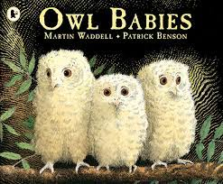  Leaf Man 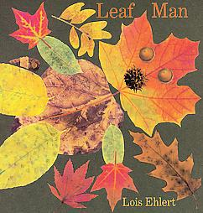  It’s not a Stick  Book Week – Aaahh Spider | Senses  Christmas  Polar bear Polar Bear 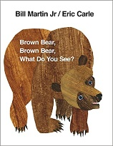  Brown Bear Brown Bear  Anna’s Amazing Multicolour glasses  Shark in the Park  Sam’s Sandwich  Alan’s Big Scary Teeth  Scaredy Squirrel  Nativity Story  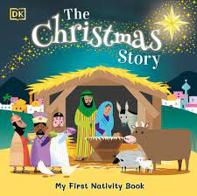 | Fairy Tales  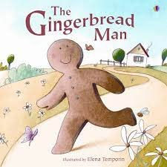  Traditional stories – The Gingerbread Man, The Three Pigs, Goldilocks and the Three bears, Jack and the Bean Stalk  The Three Billy Goats Gruff  That’s Not My Prince/Princess  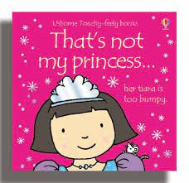 | Spring and Easter  Hattie Peck  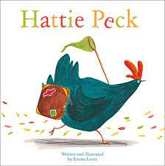  Easter story  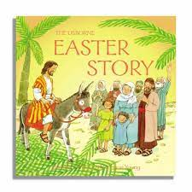 | Animals – Pets, On the Farm animals  Rosie’s Walk  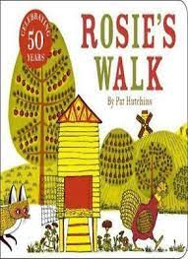  The Little Red Hen  That’s not my Puppy/kitten  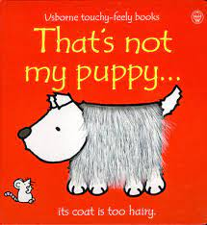 | Animals – In the Jungle, Under the Sea,  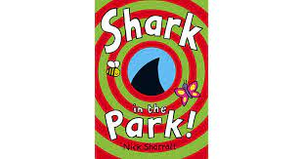  Minibeasts  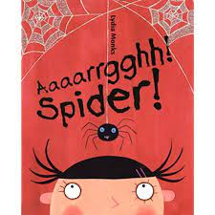  That’s not my tiger  Brown Bear Brown Bear (revisit)  Shark in the Park (revisit)  The Very Hungry Caterpillar  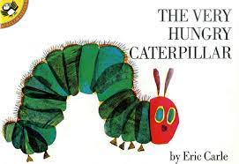  The Very Busy Spider
 | Autumn |  | Spring |  | Summer
Communication And Language
Listening, Attention & Understanding | - Listen to simple stories and understand what is happening, with the help of the pictures.  - Enjoy listening to longer stories and can remember much of what happens.  Use a wider range of vocabulary  - Pay attention to more than one thing at a time, which can be difficult. |  | - Understand a question or instruction that has two parts, such as: “Get your coat and wait at the door”.  - Understand simple questions about ‘who’, ‘what’ and ‘where’ (but generally not ‘why’). |  | - Understand ‘why’ questions, like: “Why do you think the caterpillar got so fat?”.  - Sing a large repertoire of songs.  - Know many rhymes, be able to talk about familiar books, and be able to tell a long story.
Speaking | - Develop their communication but may continue to have problems with irregular tenses and plurals, such as ‘runned’ for ‘ran’, ‘swimmed’ for ‘swam’.  - Start a conversation with an adult or a friend and continue it for many turns. |  | - Use a wider range of vocabulary.  - Use longer sentences of four or six words.  - 2.3. Use talk to organise themselves and their play: “Let’s go on a bus… you sit there… I’ll be the driver”. |  | - Be able to express a point of view to debate when they disagree with an adult or friend, using words as well as actions.  - Develop their pronunciation but may have problems saying:  - Some sounds: r, j, th, ch and sh  - Multi syllabic such as ‘pterodactyl’, ‘planetarium’ or ‘hippopotamus’.
Personal, Social & Emotional Development Skills
Self-Regulation | - Express preferences and decisions. They also try new things and start establishing their autonomy.  - Engage with others through gestures, gaze and talk. Use that engagement to achieve a goal. For example, gesture towards their cup to say they want a drink.  - Be increasingly able to talk about and manage their emotions. |  | - Begin to show ‘effortful control’. For example, waiting for a turn and resisting the strong impulse to grab what they want or push their way to the front.  - Play with one or more other children, extending and elaborating play ideas. Find solutions to conflicts and rivalries. For example, accepting that not everyone can be Spider-Man in the game, and suggesting other ideas. |  | - Feel confident when taken out around the local neighbourhood and enjoy exploring new places with their key person.  - Develop appropriate ways to be assertive.  - Talk with others to solve conflicts.
Managing Self | - Find ways of managing transitions, for example from their parent to their key person.  - Select and use activities and resources, with help when needed. This helps them to achieve a goal they have chosen, or one which is suggested for them. |  | - Increasingly follow rules, understanding why they are important. |  | - Remember rules without needing an adult to remind them.
Building Relationships | - Become more outgoing with unfamiliar people, in the safe context of their setting. |  | - Develop friendships with other children.  - Play with one or more other children, extending and elaborating play ideas.  - Notice and ask questions about differences, such as skin colour, types of hair, gender, special needs and disabilities, religion and so on. |  | - Develop their sense of responsibility and membership of a community.
Physical Development
Gross Motor Skills | - Continue to develop their movement, balancing, riding (scooters, trikes and bikes) and ball skills.  - Go up steps and stairs, or climb up apparatus, using alternate feet.  - Skip, hop, stand on one leg and hold a pose for a game like musical statues.  - Use large-muscle movements to wave flags and streamers, paint and make marks.  - Fit themselves into spaces, like tunnels, dens and large boxes, and move around in them.  - Enjoy starting to kick, throw and catch balls.  - Build independently with a range of appropriate resources. |  | - Walk, run, jump and climb – and start to use the stairs independently.  - Start taking part in some group activities which they make up for themselves, or in teams.  - Sit on a push-along wheeled toy, use a scooter or ride a tricycle.  - Match their developing physical skills to tasks and activities in the setting. For example, they decide whether to crawl, walk or run across a plank, depending on its length and width. |  | - Increasingly be able to use and remember sequences and patterns of movements which are related to music and rhythm.  - Choose the right resource to carry out their own plan. For example, choosing a spade to enlarge a small hole they dug with a trowel.  - Collaborate with others to manage large items, such as moving a long plank safely, carrying large hollow blocks.
Fine Motor Skills | - Use one-handed tools and equipment, for example, making snips in paper with scissors. |  | - Use a comfortable grip with good control when holding pens and pencils. |  | - Show preference for a dominant hand.
Health & Self-Care | - Start eating independently and learning how to use a knife and fork. |  | - Show an increasing desire to be independent, such as wanting to feed themselves and dress or undress.  - Use large and small motor skills to do things independently, for example manage buttons and zips, and pour drinks. |  | - Be increasingly independent in meeting their own care needs. E.g. Bushing teeth, using the toilet, washing and drying their hands thoroughly.  - Make healthy choices about food, drink, activity and tooth brushing.
Literacy
Word Reading | - Join in with songs and rhymes, copying sounds, rhythms, tunes and tempo.  - Say some of the words in songs and rhymes.  - Copy finger movements and other gestures or actions.  - Sing songs and say rhymes independently, for example, singing whilst playing. |  | - Notice some print, such as the first letter of their name, a bus or door number, or a familiar logo.  - Understand the five key concepts about print:  - print has meaning  - print can have different purposes  - we read English text from left to right and from top to bottom  - the names of the different parts of a book  - page sequencing  - Introduce Speed Set 1: m a s d t I n p g o c k u b f e  - Introduce reading books for sharing at home |  | - Develop their phonological awareness, so that they can:  - spot and suggest rhymes  - count or clap syllables in a word  - recognise words with the same initial sound, such as money and mother  - Begin to read individual letters by saying the sounds for them.  - Introduce Speed Set 1 (remaining): I h sh r j v y w th z chq u x ng nk  - Continue to encourage sharing reading books at home
Comprehension | - Enjoy sharing books with an adult. Pay attention and respond to the pictures or the words.  - Pay attention when listening to stories and respond to the pictures or the words  - Have favourite books and seek them out, to share with an adult, with another child, or to look at alone. |  | - Ask questions about the book. Make comments and shares their own ideas.  - Develop play around favourite stories using props. |  | - Engage in extended conversations about stories, learning new vocabulary.  - Repeat new vocabulary in a context of a story.  - Repeat words and phrases from familiar stories.
Writing | - Add some marks to their drawings, which they give meaning to. For example: “That says mummy.”  - Make marks on their picture to stand for their name.  PHYSICAL DEVELOPMENT:  - Develop manipulation and control when mark making  - Explore different materials and tools safely |  | - Write some or all of their first name.  - Begin to write initial sounds as captions for drawings.  - Use some of their print and letter knowledge in early writing such as a pretend shopping list.  PHYSICAL DEVELOPMENT:  - Use one handed tools such as scissors  - Manage buttons, zips and pour drinks  - Use a comfortable grip with good control when holding pens and pencils |  | - Write their first name independently.  - Sequence a familiar story, using pictures or props to support.  - Can add captions to their pictures using initial sounds.  PHYSICAL DEVELOPMENT:  - Show preference for a dominant hand  - Use scissors independently  - Use a comfortable grip with good control when holding pens and pencils
Mathematics
Number | - Recite numbers past 5.  - Say one number for each item in order: 1,2,3,4,5.  - Show ‘finger numbers’ up to 5.  - Joins in and sings counting songs and number rhymes. Listen to and enjoy stories that involve counting  - Climb and squeeze themselves into different types of spaces. Build with a range of resources. Complete inset puzzles. |  | - Develop fast recognition of up to 3 objects, without having to count them individually (‘subitising’).  - Link numerals and amounts: for example, showing the right number of objects to match the numeral, up to 5.  - Know that the last number reached when counting a small set of objects tells you how many there are in total (‘cardinal principle’). |  | - Develop the key skills of counting objects including saying the numbers in order and matching one number name to each item.  - Estimate and guess how many there might be before counting.
Numerical Patterns | - Notice patterns and arrange things in patterns.  - Experiments with their own symbols and marks as well as numerals. |  | - Solve real world mathematical problems with numbers up to 5.  - Compare sizes, weights etc. using gesture and language - ‘bigger/little/smaller’, ‘high/low’, ‘tall’, ‘heavy’. |  | - Use vocabulary ‘more than’, ‘less than’, ‘fewer’, ‘the same as’, ‘equal to’.  - Become familiar with some two digit numbers and start to notice patterns within them.  - Distribute items evenly from a group.
Shape | - Talk about and explore 2D and 3D shapes (for example, circles, rectangles, triangles and cuboids) using informal and mathematical language: ‘sides’, ‘corners’; ‘straight’, ‘flat’, ‘round’.  - Describe a familiar route and the order of things seen on the way.  - Understand position through words alone – for example, “The bag is under the table,” – with no pointing.  - Select shapes appropriately: flat surfaces for building, a triangular prism for a roof, etc. |  | - Discuss routes and locations, using words like ‘in front of’ and ‘behind’.  - Combine shapes to make new ones – an arch, a bigger triangle, etc.  - Begin to describe a sequence of events, real or fictional, using words such a ‘first’, ‘then’. |  | - Talk about and identify the patterns around them. For example: stripes on clothes, designs on rugs and wallpaper.  - Use informal language like ‘pointy’, ‘spotty’, ‘blobs’ etc.  - Extend and create ABAB patterns – stick, leaf, stick, leaf.  - Notice and correct an error in a repeating pattern
Understanding the World
Past and Present | - Sequence family members by size and name (baby, child, adult) |  | - Begin to make sense of their own life-story and family’s history. |  | - Comment on recent pictures of experiences in their own lives, ‘that was me at the farm…’
People, Culture and Communities | - Share likes and dislikes  - Able to say who they are and who they live with |  | - Continue developing positive attitudes about the difference between people  - Show interest in different occupations. |  | - Know that there are different countries in the world and talk about the differences they have experienced or seen in photos.
The Natural World | - Use all their senses in hands-on exploration of natural materials.  - Explore collections of materials with similar and/or different properties. Talk about what they see, using a wide vocabulary.  - Explore how things work. |  | - Plant seeds and care for growing plants.  - Understand the key features of the life cycle of a plant and an animal.  - Begin to understand the need to respect and care for the natural environment and all living things. |  | - Explore and talk about the different forces they can feel  - Talk about the difference between materials and the changes they notice
Expressive Arts and Design
Creating with Materials | - Explore different materials freely, to develop their ideas about how to use them and what to make.  - Develop their own ideas and then decide which materials to use to express them.  - Join different materials and explore different textures. |  | - Create closed shapes with continuous lines, and begin to use these shapes to represent objects.  - Draw with complexity and detail, such as representing a face with a circle and including details.  - Use drawing to represent ideas like movement or loud noises. |  | - Show different emotions in their drawing and paintings, like happiness, sadness, fear etc.  - Explore colour and colour-mixing.
Being Imaginative & Expressive | - Take part in simple pretend play, using an object to represent something else even though they are not similar.  - Begin to develop complex stories using small world equipment like animal sets, dolls and dolls houses, etc.  - Make imaginative and complex ‘small worlds’ with blocks and construction kits, such as a city with different buildings and a park. |  | - Listen with increased attention to sounds.  - Respond to what they have heard, expressing their thoughts and feelings.  - Remember and sing entire songs.  - Play instruments with increasing control to express their feelings and ideas. |  | - Sing the pitch of a tone sung by another person (‘pitch match’).  - Sing the melodic shape (moving melody, such as up and down, down and up) of familiar songs.  - Create their own songs, or improvise a song around one they know.

