Reception Weekly Writing Focused Outcomes 2024 - 2025

 | Magnificent Me
Autum 1 texts & outcomes | Key Text |  |  | Week 1 |  |  |  |  |  | Week 2 |  |  |  |  | Week 3 |  |  |  |  |  | Week 4 |  |  |  |  |  | Week 5 |  |  |  |  | Week 6 |  |  |  |  | Week 7
 | Barefoot book of children  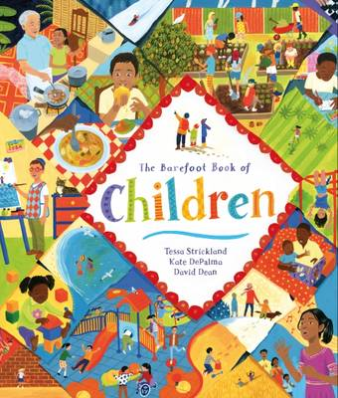  We are family – Hegarty /Usborne book of family  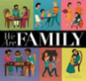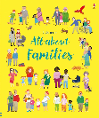  Supertato –  Hendry & Linnet  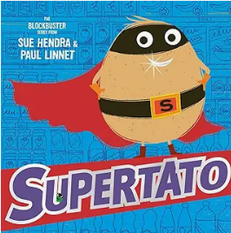  The squirrels that squabbled –  Bright & Field  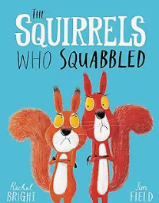 |  |  | Barefoot book of children:  All about me  Using mirrors to draw self portraits  Lots of creative activities on formation, exploring line and control. |  |  |  |  |  | Emotions  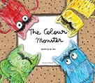  The Colour Monster – Llenas  Ensure that pupils understand that marks make meanings. |  |  |  |  | We are family:  Share pages to encourage discussion and extend vocabulary. Pupils will be able to give meaning to the marks they make about their family. Key vocabulary – family, similar, different, special , skin colour, naming family members  Discuss what makes us the same and what makes us different  A daily focus on pupils writing their own name across the half term.  Action songs – Pat a cake, Head, shoulders knees and toes, This old man (extending vocabulary_) |  |  |  |  |  | Supertato:  Create a scene from the story where the evil pea has ‘attacked’ one of the vegetables.  Re-enact parts of the story and use story telling suitcases and story maps to capture the sequence.  Add post-it notes of initial sounds to the map.  Guided Group write – Letter formation & oral blending of simple words. Focus initial sounds  S A T P I N M D G O C K CK  High frequency words through reading and writing is, I  IS and I  Orally innovate the story using props. pupils capture their ideas through art, mark making /initial sounds and discussion with teachers eg. He is bad. He is mad.  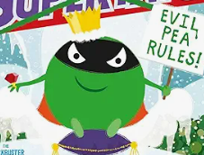 |  |  |  |  |  |  |  |  |  |  | The Squirrels that squabbled:  (linked to understanding of the world)  Role play: Teachers have a squabble that introduces the story of the fighting squirrels  Speech bubble from Cyril about his predicament.  Map of the nutty nut race which is labelled using phonic skills.  Watch clips of hibernating animals and draw 5 of them and use phonics to label them.  Film pupils re-enacting and telling the story /create an assembly for parents to showcase the story  Make autumn poem based on The Squirrels and what happens in autumn?  Leaves flutter, flutter flutter.  Conkers crack, crack, crack.  Acorns drop, drop, drop etc.  Guided group work – linked directly to phonics  High frequency words through reading and writing the, is, I  Writing assessment: name  Assess Write Dance impact with all children to ascertain groups after half term
Supplementary texts | You Choose –  Goodhart & Sharratt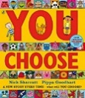  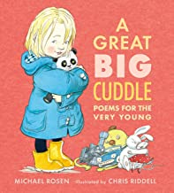  A great big cuddle – Rosen |  |  | Funny Bones – Ahlberg  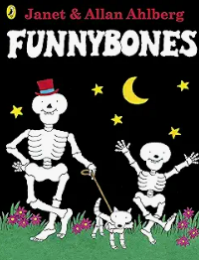  Hello World – My Body – McDonald  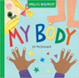 |  |  |  |  |  | Everybody feels Happy/sad – Butterfield  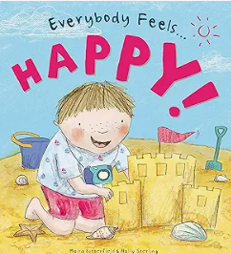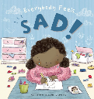  The good mood hunt – Oram & Partis  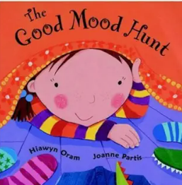 |  |  |  |  | In every house in  every street –  Hitchman & Baleine  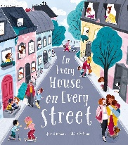 |  |  |  |  |  | When we grow up – Walsh  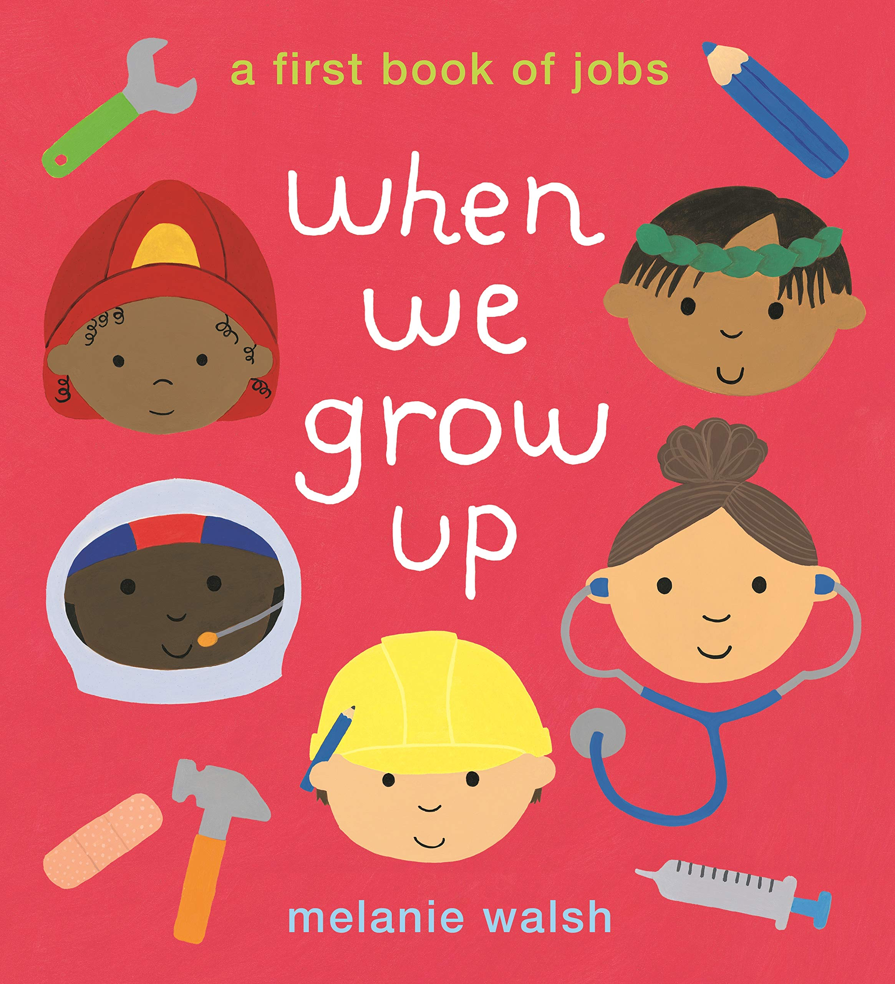 |  |  |  |  |  |  |  |  |  |  | 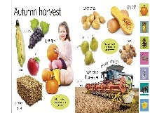  My first seasons book – DK  (dipped into across the year)  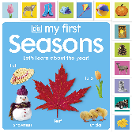  Out and about –– Hughes  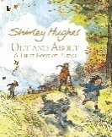
Autumn 2 Texts and outcomes | CELEBRATIONS
 | Key Text | Week 1 |  |  |  |  |  | Week 2 |  |  |  |  | Week 3 |  |  |  |  |  | Week 4 |  |  | Week 5 |  |  |  |  |  | Week 6 |  |  |  |  | Week 7 |  |  |  |  | Week 8
 | Seasons & What do we celebrate?  Pumpkin Soup – Cooper  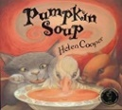  Diwali – Acorn pub.  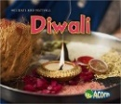  The Bog Baby – Willis & Millward  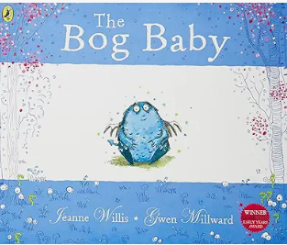  The Nativity – Guillian & Grainger  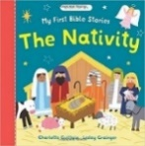  Stick Man – Donaldson  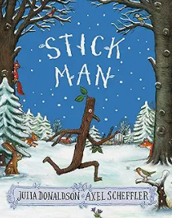 | Pumpkin Soup:  Introduce the story of pumpkin soup as a hook for the D.T. focus  Describe the pumpkins (from a big display)  Write a shopping list for making the soup.  Sequence the instructions for making soup.  Create a soup package design that they label.  Use Mrs Blackhat to help pupils decide what to put in their magic rhyming soup and write a list with CVC words eg. rat, bat,  Build up sentences eg  Put the rat in the pan.  Daily whole name writing |  |  |  |  |  |  |  |  |  |  | Remembrance Day  Use images from Where the poppies now grow – pupils create simple sentences capturing the event in one of the pages |  |  |  |  |  | The Bog Baby – Willis???  (to be discussed)  Introduce the story and our own class bog baby. We need to look after our bog baby – allocated child to look after our bog baby each day and to write sentences in the class bog baby book.  What do we need to survive?  How can we look after something/someone/ourselves?  Looking into friendships, kindness, PSHE.  Draw and label bog baby.  Write instructions for how to look after our bog baby.  It has…  It needs…  The bog baby needs… |  |  |  |  |  |  |  |  | The Nativity:  Recognise key characters from the story.  Listen to the story and watch the rehearsal for the Year 1 Nativity.  Draw the scene in the stable and add a simple sentence capturing it.  Twinkle Twinkle Little Star |  |  |  |  | Stick Man  Label and describe what to wear in winter using high frequency words, their phonics skills and understanding of the demarcated sentence  as and has his her to into he of we me be  He has a ……  Her hat is ……  Assessment: to write their full name
Diwali
Diwali information text and clips about the festival and celebrations

Make, label Diwali card

Invite a Hindu person in to describe Diwali, learn form then and write a letter of thanks for their visit.
Supplementary texts |  | Mrs Blackhat – Inkpen/  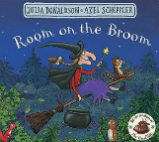  Room on the Broom – Donaldson  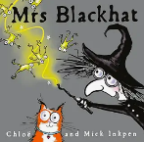  Binny’s Diwali – Umrigar & Chanani  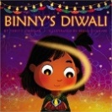 |  |  |  |  |  |  |  |  |  |  | Where the Poppies now grow  Robinson & Impey  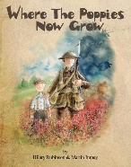 |  |  |  |  |  | Best Birthday present ever – Mantle  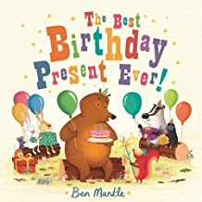 |  |  |  |  |  |  |  |  | First book of nature – Davies  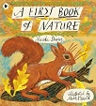 |  |  |  |  | My first seasons book – DK  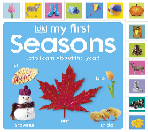  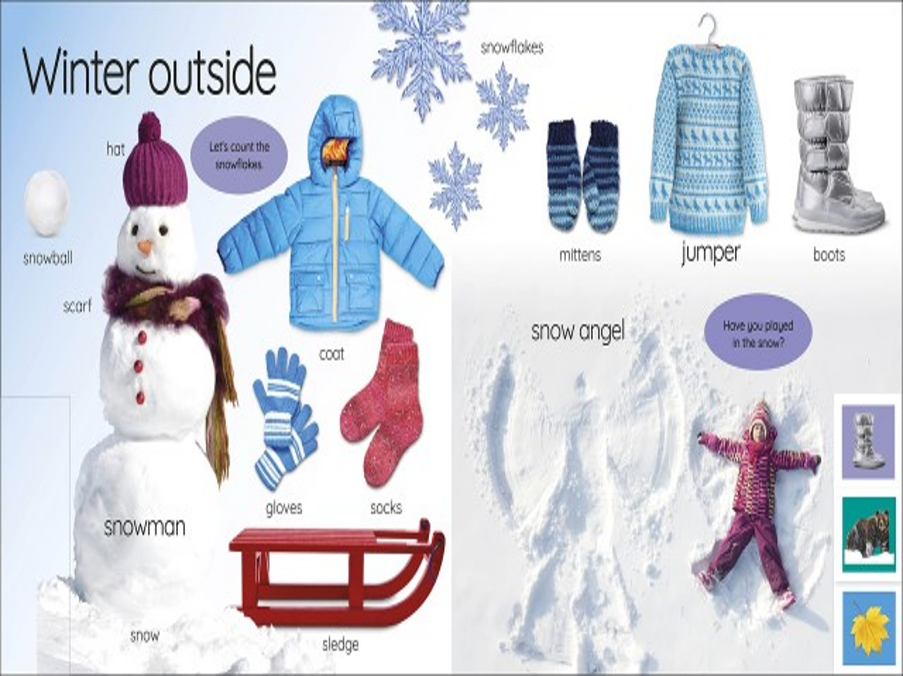
Spring 1 Texts and outcomes | WINTER & (CELEBRATIONS)
 | Key Text |  | Week 1 |  |  |  |  |  | Week 2 |  |  |  |  | Week 3 |  |  |  |  |  | Week 4 |  |  |  |  |  | Week 5 |  |  |  |  | Week 6 |  |  |  |  | Week 7
 | 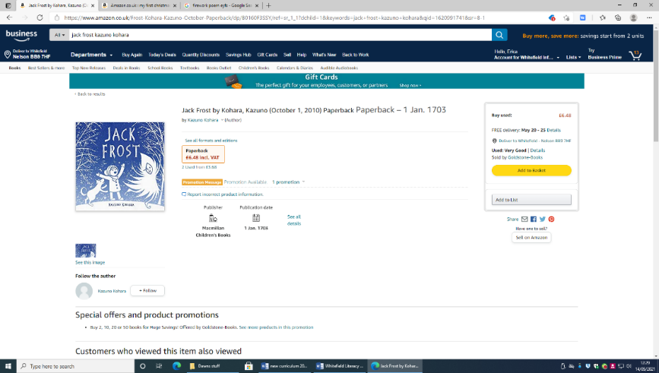  Jack Frost – Kazuno  One Snowy Night – Inkpen/ The Gruffalo’s Child – Donaldson  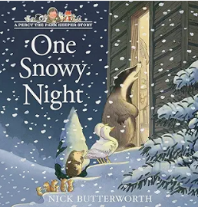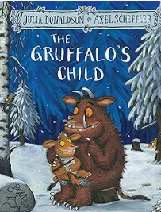  Lunar New Year – First Festivals  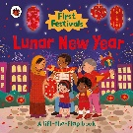  We’re going on a bear hunt – Rosen  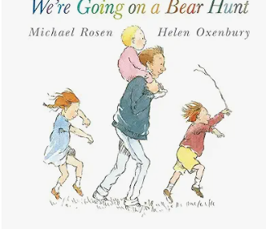  Rabbit’s pancake Picnic –  Evans & Bowles  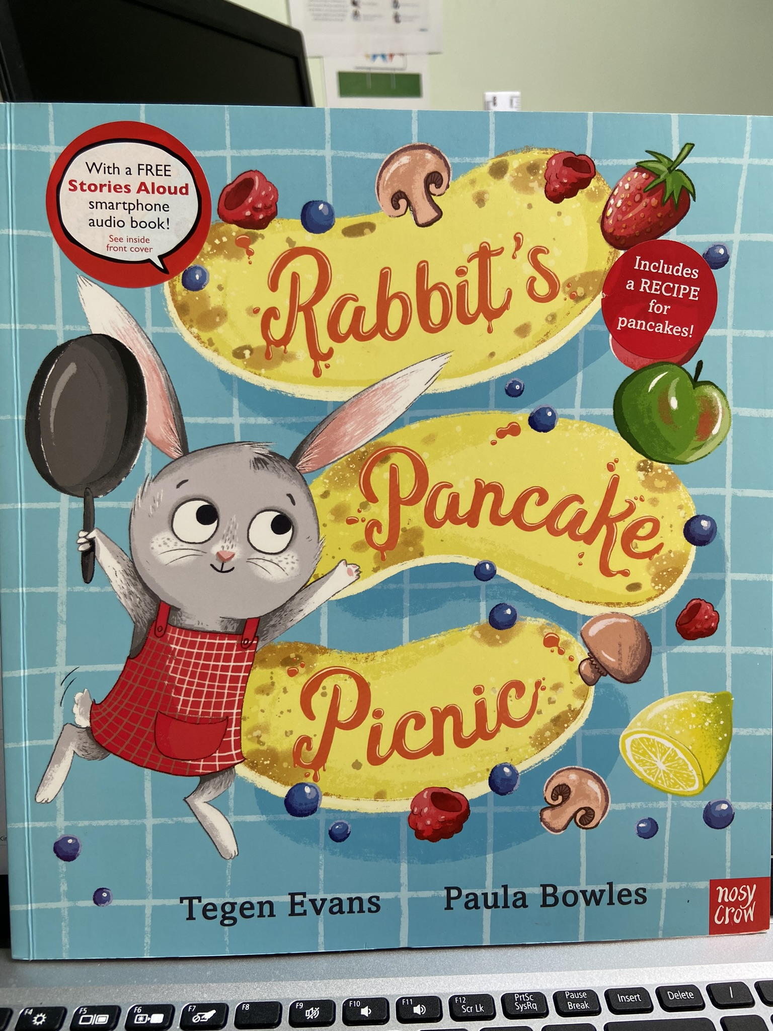 |  | What can you see in Winter? – Smith  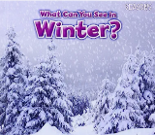  Jack Frost: |  |  |  |  |  | One Snowy Night –  Gruffalo Child :  Writing some of the tricky words such as I, me, my, like, to, the. Writing CVC words. Labels using CVC, CVCC, CCVC words.  Guided writing based around developing short sentences in a meaningful context.  Create a story board. Practising correct letter formation.  Begin to write simple sentences.  ‘Hold and write a sentence’.  Creating own story maps, writing captions and labels, writing simple sentences.  Writing short sentences to accompany story maps.  Labels and captions.  Write a sentence.  Ensuring correct letter formation. |  |  |  |  |  |  |  |  |  |  | Chinese New Year  Other cultures – what do other cultures celebrate?  Food tasting – dancing and music.  Creating our own dances for CNY  Invitations to CNY party – have one on the Friday |  |  |  |  |  | We’re going on a bear hunt – Rosen  Descriptive words – bear  ELG: Write simple sentences and phrases that can be read by others.  Write short sentences with words with known letter-sound correspondences.  Write some letters accurately.  ELG: Demonstrate understanding of what has been read to them by retelling stories and narratives using their own words and recently introduced vocabulary.  Write short sentences with words with known letter-sound correspondences.  Tell the children they are going to be acting the story of We’re going on a bear hunt out tomorrow. Explain that they might need some props to act it out (such as a bear) model writing a list of what they think they will need. Children to write a list of things they will need to act out the story.  Recount of story.  Act outside using props, story map, create the areas they visit within the outside area (field?) |  |  |  |  |  |  |  |  |  |  | Rabbit’s  Pancake Picnic  Speech bubbles for characters.  Understanding that different characters can talk even if not in story. Creating our own thoughts and speech for each character.  Comparing characters. Comparing settings. Changing the story.  Story mapping – talking.  Make pancakes and have a pancake picnic.
Supplementary texts | A stroll through the seasons – Barnham  (dip in over  the year)  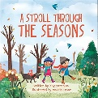 |  | My first seasons book – DK |  |  |  |  |  | I definitely don’t like winter – Barker & Pym  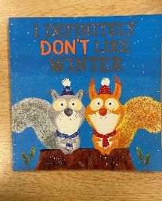 |  |  |  |  |  |  |  |  |  |  | I love Chinese New Year – Nava  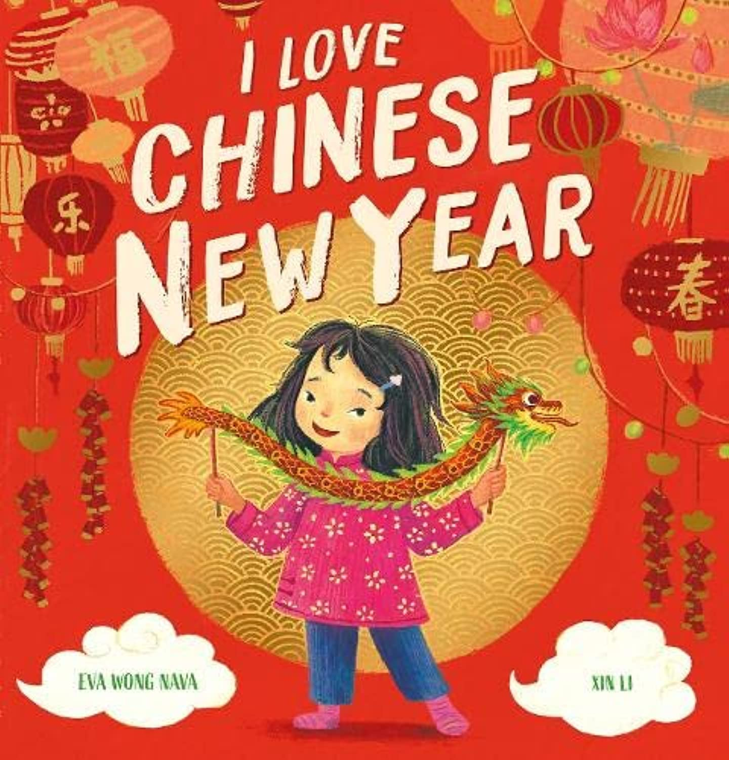  The Runaway wok –Compestine & Serra  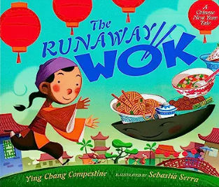 |  |  |  |  |  |  |  |  |  |  |  |  |  |  |  |  | Mr Wolf’s pancakes - Fearnley  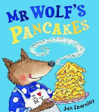  Pancakes, pancakes – Carle  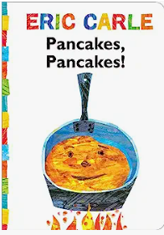
 | GROWING
Spring 2 Texts and outcomes | Key Text |  |  |  | Week 1 |  |  |  |  |  | Week 2 |  |  |  |  |  | Week 3 |  |  |  |  |  | Week 4 |  |  |  |  |  | Week 5 |  |  |  |  |  | Week 6
 | Jack and the beanstalk - Alperin  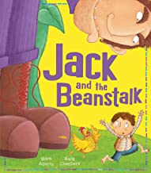  Plant the Tiny Seed Matheson  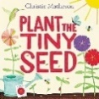  Lola Plants a Garden – McQuinn  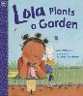  Frog – Li /Little Frog – Autumn Publishing  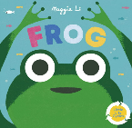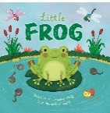  Tadpoles Promise – Willis  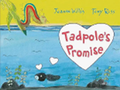 |  |  |  | Jack and the beanstalk:  Hook - a beanstalk has grown in the classroom as the initial hook.  Prediction sentences about what could be at the top of your beanstalk.  Growing spell –  Perform  Tall tall tall  Grow, grow, grow  Stretch, stretch, stretch  How does the beanstalk feel? (look at different pictures)  I’m a beanstalk, bursting…  I’m a beanstalk stretching..... Collect words – act out growing, bursting, stretch, twisting, climbing ... become beanstalks and talk photos.  Start telling the narrative using props and images from the story to lead into the writing and begin to retell.  Missing poster for Jack from his mothers.  Character study of giant - describe giant  Compare to other pictures of giants / watch BFG clip  Giant’s speech bubble shouting at Jack (more able will begin to use and)  Letter of apology from Jack to the giant for stealing the harp/chicken. |  |  |  |  |  |  |  |  |  |  |  | Lola Plants a Garden: (Used as a stimulus for how to plant  Label their observational drawing of a flower eg. stem, root, petal, leaf.  Plant the Tiny Seed  Simple instructions to tell Lola how to plant a seed/cress.  Pupils will plant cress. Record their observations and write captions.  I’m a little seed  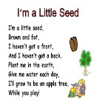 |  |  |  |  |  | Frogs & lifecycles
 |  |  |  |  |  |  |  |  |  |  |  |  |  |  |  |  |  |  |  |  |  |  | Frog /Little Frog  Setting – the pond. Work around our pond in school. What does it look like? List of what we can see at the pond using clipboards and pencils.  Labelling a pond and creating mini ponds in a jar in the classroom. |  |  |  |  |  | Tadpole’s Promise  Hook – tadpoles within a jar appear in the classroom. Where could they have come from?  Who what when where why?  Life cycle of a frog and butterfly/caterpillar  Caterpillars in class to release or tadpoles to put in the pond?
Supplementary texts | The booktime book of fantastic first poems – edited Crebbin  (dipped into  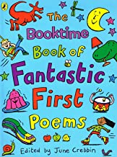  across the year) |  |  |  | Jasper’s beanstalk – Butterworth & Inkpen  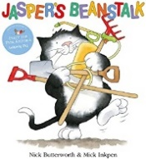  Jack and the jellybean stalk – Mortimer  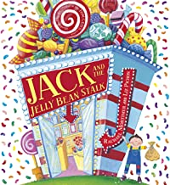 |  |  |  |  |  |  |  |  |  |  |  | One Little Seed - Davies  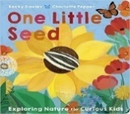  Little green helpers – Grow – Engel  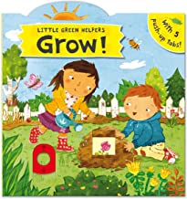 |  |  |  |  |  | Oi Frog – Gray & Field  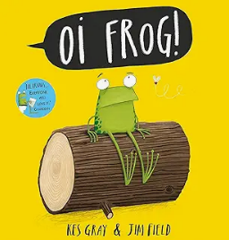
Summer 1 Texts and outcomes | ANIMALS
 | Key Text |  |  |  |  |  | Week 1 |  |  |  |  |  |  |  |  | Week 2 |  |  |  |  |  |  |  |  | Week 3 |  |  |  |  |  |  |  |  | Week 4
 | Dear Zoo – Campbell  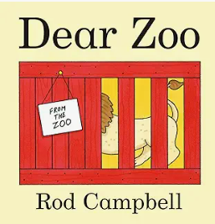  Never Tickle a tiger –  Butchart & Boutavant  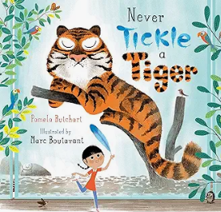  Supermarket Zooopermarket – Sharratt  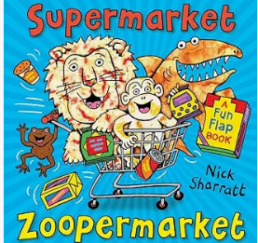 |  |  |  |  |  | Dear Zoo  Letters to the zoo and from the zoo. Using ‘because’ to create longer sentences.  “I sent the elephant back because it was too big.” Etc.  Label their own zoo – which animals will they include in their zoo and why?  Simple fact file about an animal of their choice. E.g. zebra, elephant, snake, etc. Using factual and descriptive sentences. |  |  |  |  |  |  |  |  |  |  |  |  |  |  |  |  |  | Never Tickle a tiger  Discuss what we already know about zoos. What animals there? Etc.  Begin to read story – areas made into a zoo, etc.  Write lists for what not to do with a tiger and what to do.  Repeat for other animals.  E.g. never tickle, push, hit, etc.  Always feed, stroke, greet, look, etc. |  |  |  |  |  |  |  |  | Supermarket Zooopermarket  Lists of what we would buy from the supermarket zoopermarket.  Compare this supermarket to a normal one.  Role play in supermarket – language of asking questions and giving reasoning.  Label animals in the supermarket and design pour own.  Letter to the supermarket (e.g. asda) to ask for them to really have the products in them.
Supplementary Texts | 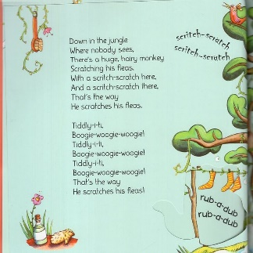  Down in the jungle – song/rhyme |  |  |  |  |  | 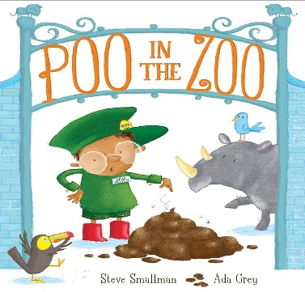  Poo in the zoo – Steve smallman  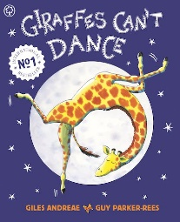  Giraffes can’t dance – Giles Andraea |  |  |  |  |  |  |  |  |  |  |  |  |  |  |  |  |  | 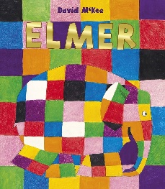  Elmer – David McKee |  |  |  |  |  |  |  |  | 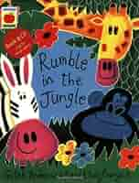  Rumble in the jungle
Summer 2 Texts and outcomes | ALL AROUND THE WORLD
 | Key Text |  |  |  |  | Week 1 |  |  |  |  |  | Week 2 |  |  |  |  |  | Week 3 |  |  |  |  |  | Week 4 |  |  |  |  |  | Week 5 |  |  |  |  | Week 6
 | Core Text  Snail and the whale – Donaldson & Scheffler  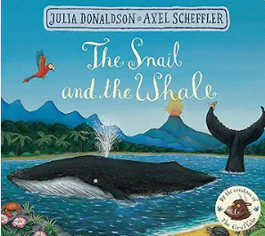 |  |  |  |  | Cold lands  Begin story of snail and whale. Introduce using feely tub. Map to find where the snail and the whale may go. Predictions, etc.  Begin to read one day in our blue planet = first part of story.  Setting descriptions for cold lands. What animas live here? What is the setting like?  Setting description – labelling and using adjectives to describe the setting. |  |  |  |  |  |  |  |  |  |  |  | Hot lands  Move onto next part of snail and whale. Next where do the snail and whale travel to? – hot lands, Hawaii, etc.  Begin to read one day in our blue planet = second part of story.  Setting descriptions for hot lands. What animas live here? What is the setting like? How are they different?  Setting description. Labelling differences between the two settings discussed so far. |  |  |  |  |  |  |  |  |  |  |  | Under the sea  Move onto next part of snail and whale. Next where do the snail and whale travel to? – Under the sea, coral reefs, etc.  Begin to read one day in our blue planet = third part of story.  Setting descriptions for under the sea. What animas live here? What is the setting like? How are they different?  Draw/label the map of the journey of the animals.  Create their own journey/ instructions.  E.g. Firstly go to the cold icy lands. Then go to the hot dry desert. Finally go to the deep dark ocean.
Supplementary texts | Children’s Picture Atlas  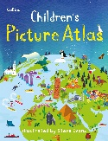 |  |  |  |  | One day on our blue planet – Antarctic  Bailey  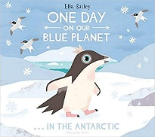 |  |  |  |  |  |  |  |  |  |  |  | One day on our blue planet – Rainforest Bailey  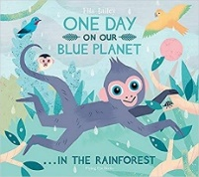 |  |  |  |  |  |  |  |  |  |  |  | One day on our blue planet … in the ocean – Bailey  